**PRACTICAL NO:- 1**

**TO IMPLEMENT A SERVER CALCULATOR USING RPC CONCEPT. (MAKE USE OF DATAGRAM)**

# PRACTICAL NO:- 1

## Aim:- To implement a Server calculator using RPC concept. (Make use of datagram) Code:-

**RPCServer.java:-**

//To Implement a server calculator containing ADD(),MUL(),SUB() import java.util.*;

import java.net.*; class RPCServer

{

DatagramSocket ds;

DatagramPacket dp;

String str, methodName, result; int val1,val2;

RPCServer()

{

try

{

ds=new DatagramSocket(1200); byte b[]=new byte[4096];

// int a[]=new int[100]; while(true)

{

dp=new DatagramPacket(b,b.length); ds.receive(dp);

str=new String(dp.getData(),0,dp.getLength()); // add 10 20

if(str.equalsIgnoreCase("q"))

{

System.exit(1);

}

else

{

StringTokenizer st = new StringTokenizer(str," "); int i=0;

while(st.hasMoreTokens())

{

// String token=st.nextToken(); methodName=st.nextToken(); // add val1 = Integer.parseInt(st.nextToken()); // 10

val2 = Integer.parseInt(st.nextToken()); // 20

}

}

1300);

System.out.println(str); // print add 10 20 InetAddress ia = InetAddress.getLocalHost(); if(methodName.equalsIgnoreCase("add"))

result= "" + add(val1,val2);

else if(methodName.equalsIgnoreCase("sub")) result= "" + sub(val1,val2);

else if(methodName.equalsIgnoreCase("mul")) result= "" + mul(val1,val2);

else if(methodName.equalsIgnoreCase("div")) result= "" + div(val1,val2);

byte b1[]=result.getBytes(); // convert string data into byte DatagramSocket ds1 = new DatagramSocket();

DatagramPacket dp1 = new DatagramPacket(b1,b1.length,InetAddress.getLocalHost(),

System.out.println("result : "+result+"\n"); ds1.send(dp1);

}

}

catch (Exception e)

{

e.printStackTrace();

}

}

|  |  |  |  |
| --- | --- | --- | --- |
| public int add(int val1, int val2) | { | return val1+val2; | } |
| public int sub(int val3, int val4) | { | return val3-val4; | } |
| public int mul(int val3, int val4) | { | return val3*val4; | } |
| public int div(int val3, int val4) | { | return val3/val4; | } |

public static void main(String[] args){ new RPCServer(); }

}

**RPCClient.java:-** import java.io.*; import java.net.*; class RPCClient

{

RPCClient()

{

try

{

InetAddress ia = InetAddress.getLocalHost(); DatagramSocket ds = new DatagramSocket(); DatagramSocket ds1 = new DatagramSocket(1300); System.out.println("\nRPC Client\n");

System.out.println("Enter method name and parameter like add 10 20\n"); System.out.println("Press \'q\' to quit \n");

while (true)

{

BufferedReader br = new BufferedReader(new InputStreamReader(System.in)); String str = br.readLine();

byte b[] = str.getBytes();

DatagramPacket dp = new DatagramPacket(b,b.length,ia,1200); ds.send(dp);

dp = new DatagramPacket(b,b.length); ds1.receive(dp);

String s = new String(dp.getData(),0,dp.getLength()); System.out.println("\nResult = " + s + "\n");

}

}

catch (Exception e)

{

e.printStackTrace();

}

}

public static void main(String[] args)

{

new RPCClient();

}

}

**Output:-**

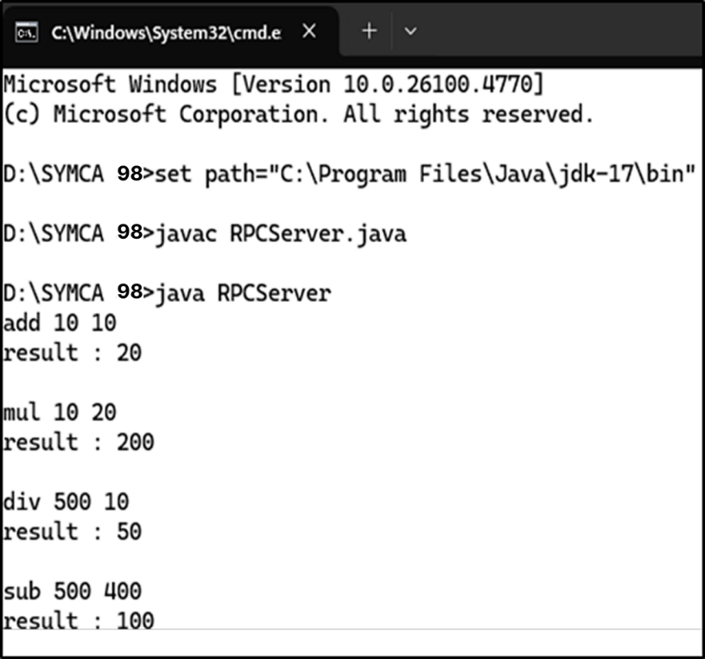

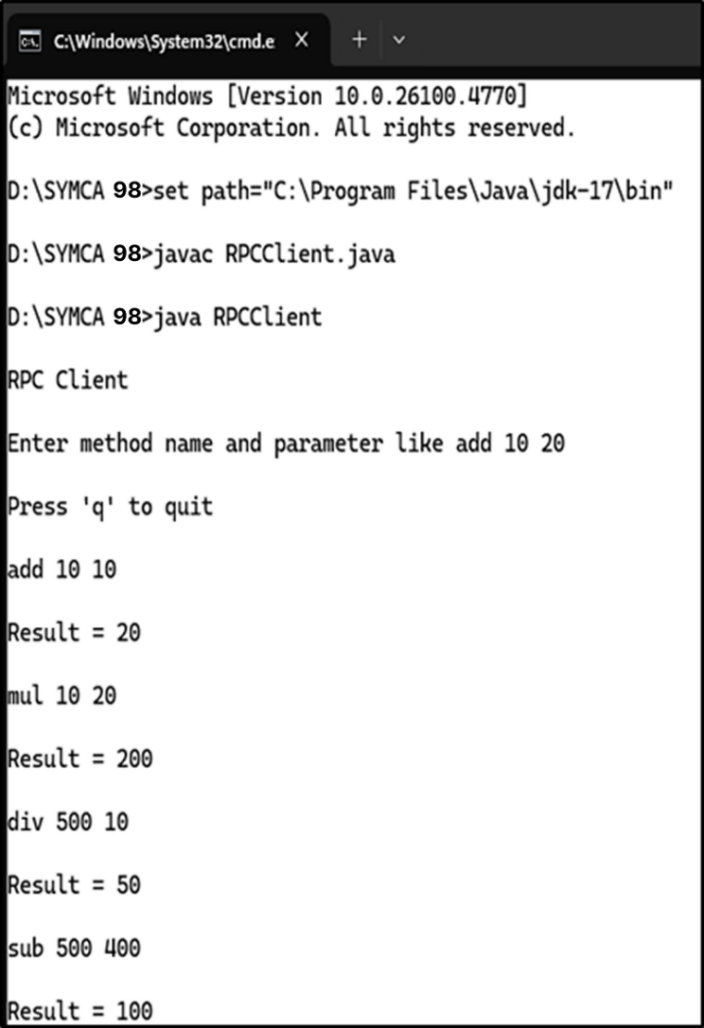

**PRACTICAL NO :-2**

**TO IMPLEMENT A DATE TIME SERVER USING RPC CONCEPT. (MAKE USE OF DATAGRAM)**

# PRACTICAL NO :-2

## Aim:- To implement a Date Time Server using RPC concept. (Make use of datagram). Code:-

**RPCServer1.java:-**

//To Implement a Date time server containing date() and time() procedure. import java.util.*;

import java.net.*;

import java.text.SimpleDateFormat; class RPCServer1

{

DatagramSocket ds;

DatagramPacket dp;

String str, methodName, result; int val1,val2;

RPCServer1()

{

try

{

ds=new DatagramSocket(1200); byte b[]=new byte[4096];

while(true)

{

dp=new DatagramPacket(b,b.length); ds.receive(dp);

str=new String(dp.getData(),0,dp.getLength());

if(str.equalsIgnoreCase("q"))

{ System.exit(1); } else

{

StringTokenizer st = new StringTokenizer(str," "); int i=0;

while(st.hasMoreTokens())

{

methodName=st.nextToken();

}

}

Calendar c = Calendar.getInstance();

SimpleDateFormat dateFormat = new SimpleDateFormat("dd/MM/yyyy");

Date d = c.getTime();

InetAddress ia = InetAddress.getLocalHost();

1300);

}

if(methodName.equalsIgnoreCase("date")) result=""+ dateFormat.format(d);

else if(methodName.equalsIgnoreCase("time"))

result= "" + d.getHours() +" : " +d.getMinutes() + " : " +d.getSeconds(); byte b1[]=result.getBytes();

DatagramSocket ds1 = new DatagramSocket();

DatagramPacket dp1 = new DatagramPacket(b1,b1.length,InetAddress.getLocalHost(),

System.out.println("result : "+result+"\n"); ds1.send(dp1);

}

catch (Exception e)

{

e.printStackTrace();

}

}

public static void main(String[] args)

{

new RPCServer1();

}

}

**RPCClient1.java:-** import java.io.*; import java.net.*;

class RPCClient1

{

RPCClient1()

{

try

{

InetAddress ia = InetAddress.getLocalHost();

DatagramSocket ds = new DatagramSocket(); DatagramSocket ds1 = new DatagramSocket(1300);

byte b1[]=new byte[50]; System.out.println("\nRPC Client\n"); while (true)

{

BufferedReader br = new BufferedReader(new InputStreamReader(System.in)); String str = br.readLine();

byte b[] = str.getBytes();

DatagramPacket dp = new DatagramPacket(b,b.length,ia,1200); ds.send(dp);

if(str.equalsIgnoreCase("q"))

{

System.out.println("server exited..."); System.exit(1);

}

dp = new DatagramPacket(b1,b1.length); ds1.receive(dp);

String s = new String(dp.getData(),0,dp.getLength()); System.out.println("\n Result = " + s);

}

} // end of try block catch (Exception e)

{

e.printStackTrace();

}

} // end of constructor

public static void main(String[] args)

{

new RPCClient1();

}

}

**Output:-**

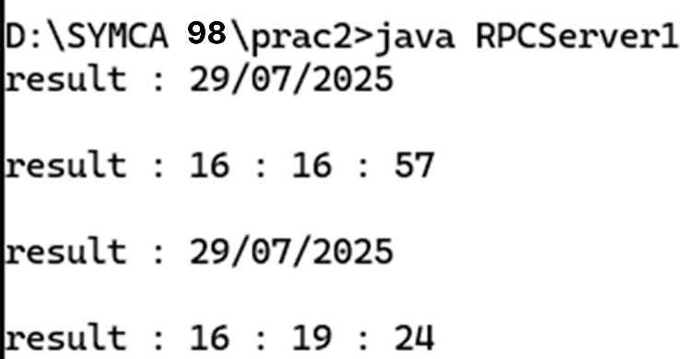

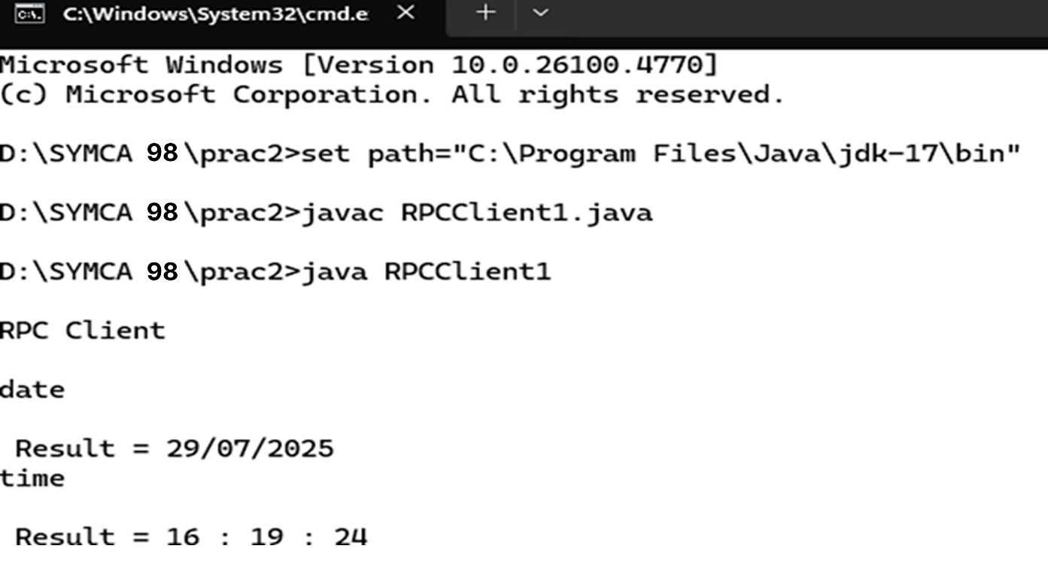

**PRACTICAL NO :- 3**

**TO IMPLEMENT A SERVER CALCULATOR USING RPC CONCEPT. (MAKE USE OF SERVER SOCKET)**

# PRACTICAL NO :- 3

## Aim:- To implement a Server calculator using RPC concept. (Make use of Server Socket).

**Code:- Server.java:-**

// Server.java

// Import necessary classes for input/output and networking

import java.io.*; // For BufferedReader, InputStreamReader, PrintWriter import java.net.*; // For ServerSocket and Socket

// Define the Server class public class Server

{

public static void main(String[] args)

{

int port = 5000; // Define the port number where the server will listen

// Try-with-resources to automatically close ServerSocket when done try (ServerSocket serverSocket = new ServerSocket(port))

{

System.out.println("Calculator Server is running on port " + port);

// Infinite loop to continuously accept client connections while (true)

{

// Wait and accept a client connection Socket clientSocket = serverSocket.accept(); System.out.println("Client connected");

// Create input stream to read data sent by the client BufferedReader in = new BufferedReader(new

InputStreamReader(clientSocket.getInputStream()));

// Create output stream to send data back to the client

PrintWriter out = new PrintWriter(clientSocket.getOutputStream(), true);

// Read the operation request sent by the client String request = in.readLine(); System.out.println("Request received: " + request);

// Process the request and generate the response String response = handleRequest(request);

// Send the response back to the client out.println(response);

// Close the client socket after responding clientSocket.close();

}

}

catch (IOException e)

{

// Handle exceptions related to networking e.printStackTrace();

}

}

// Method to handle the operation request sent by the client private static String handleRequest(String request)

{

// Split the request string into parts (operation, operand1, operand2) String[] tokens = request.split(" ");

// If the input is not in correct format, return error message if (tokens.length != 3)

return "Invalid format. Use: operation operand1 operand2";

// Convert the operation to lowercase for case-insensitive comparison String operation = tokens[0].toLowerCase();

double num1, num2; // Variables to hold the numeric operands try

{

// Parse the operand strings into numbers num1 = Double.parseDouble(tokens[1]); num2 = Double.parseDouble(tokens[2]);

}

catch (NumberFormatException e)

{

// Return error message if operands are not valid numbers return "Invalid numbers.";

}

// Perform the operation based on the operator switch (operation)

{

case "add":

return String.valueOf(num1 + num2); // Addition case "sub":

return String.valueOf(num1 - num2); // Subtraction case "mul":

return String.valueOf(num1 * num2); // Multiplication

case "div":

if (num2 == 0)

return "Division by zero error."; // Handle division by zero return String.valueOf(num1 / num2); // Division

default:

return "Unsupported operation: " + operation; // If operation is not recognized

}

}

}

## Client.java:-

// Client.java

import java.io.*; // For InputStreamReader, BufferedReader, PrintWriter import java.net.*; // For Socket class (network communication)

import java.util.Scanner; // For reading input from the user

// Client class public class Client

{

public static void main(String[] args)

{

// Host and port where the server is running String host = "localhost";

int port = 5000;

// Try-with-resources to automatically close the socket when done try (Socket socket = new Socket(host, port))

{

// Create a PrintWriter to send data to the server

PrintWriter out = new PrintWriter(socket.getOutputStream(), true);

// Create a BufferedReader to read data from the server BufferedReader in = new BufferedReader(

new InputStreamReader(socket.getInputStream()));

// Scanner to get user input from the console Scanner scanner = new Scanner(System.in);

System.out.println("Enter operation (e.g., add 10 5): ");

String input = scanner.nextLine(); // Read the operation from user

// Send the input operation to the server out.println(input);

// Read the server's response

String response = in.readLine(); System.out.println("Result from server: " + response);

}

catch (IOException e)

{

// Handle exceptions related to networking e.printStackTrace();

}

}

}

**Output:-**

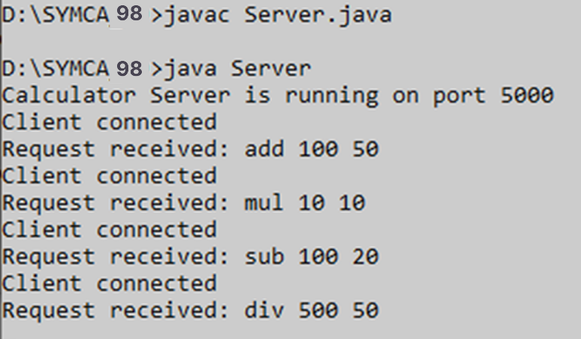

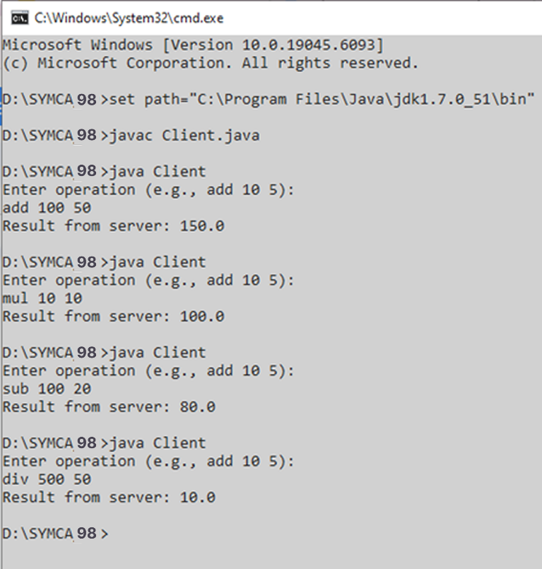

**PRACTICAL NO:- 4**

**TO IMPLEMENT A DATE TIME SERVER USING RPC CONCEPT. (MAKE USE OF SERVER SOCKET)**

# PRACTICAL NO:- 4

## Aim:- To implement a Date Time Server using RPC concept. (Make use of Server Socket).

**Code:- DateTimeServer.java:-**

//DateTimeServer.java import java.io.*; import java.net.*;

import java.time.LocalDateTime;

import java.time.format.DateTimeFormatter; public class DateTimeServer {

public static void main(String[] args) { int port = 6000;

try (ServerSocket serverSocket = new ServerSocket(port)) { System.out.println("DateTime Server is running on port " + port); while (true) {

Socket clientSocket = serverSocket.accept(); System.out.println("Client connected"); BufferedReader in = new BufferedReader(

new InputStreamReader(clientSocket.getInputStream())); PrintWriter out = new PrintWriter(clientSocket.getOutputStream(), true); String request = in.readLine();

System.out.println("Received request: " + request); String response = handleRequest(request); out.println(response);

clientSocket.close();

}

} catch (IOException e) { e.printStackTrace();

}

}

private static String handleRequest(String request) { if ("getDateTime".equalsIgnoreCase(request)) {

LocalDateTime now = LocalDateTime.now();

DateTimeFormatter formatter = DateTimeFormatter.ofPattern("yyyy-MM-dd HH:mm:ss");

return now.format(formatter);

} else {

return "Invalid RPC method. Use 'getDateTime'";

}

}

}

## DateTimeClient.java:-

// DateTimeClient.java import java.io.*; import java.net.*;

public class DateTimeClient {

public static void main(String[] args) { String host = "localhost";

int port = 6000;

try (Socket socket = new Socket(host, port)) {

PrintWriter out = new PrintWriter(socket.getOutputStream(), true); BufferedReader in = new BufferedReader(

new InputStreamReader(socket.getInputStream())); out.println("getDateTime"); // RPC-style command String response = in.readLine(); System.out.println("Server DateTime: " + response);

} catch (IOException e) { e.printStackTrace();

}

}

}

**Output:-**

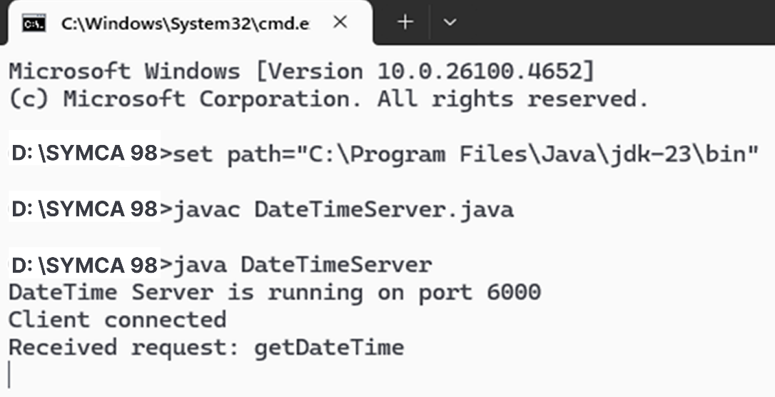

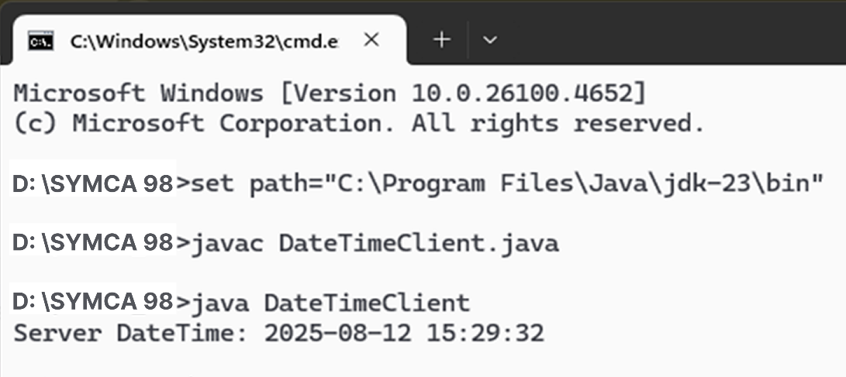

**PRACTICAL NO :- 5**

**TO RETRIEVE DAY, TIME AND DATE FUNCTION FROM SERVER TO CLIENT. THIS PROGRAM**

**SHOULD DISPLAY SERVER DAY, TIME AND DATE. (USE CONCEPT OF JDBC AND RMI FOR ACCESSING MULTIPLE**

**DATA ACCESS OBJECTS)**

# PRACTICAL NO :- 5

## Aim:- To retrieve day, time and date function from server to client. This program should display server day, time and date. (Use Concept of JDBC and RMI for accessing multiple data access objects)

**Code:- IDate.java:-**

// IDate.java import java.rmi.*;

public interface IDate extends Remote

{

String getDate() throws RemoteException;

}

DateServer.java

// DateServer.java import java.rmi.*; public class DateServer

{

public static void main(String[] args)

{

try

{

DateImpl di=new DateImpl(); Naming.rebind("DServer",di);

System.out.println("Date Server is Ready");

}

catch(Exception e)

{

e.printStackTrace();

}

}

}

## DateImpl.java:-

// DateImpl.java import java.rmi.*;

import java.rmi.server.*; import java.util.*;

public class DateImpl extends UnicastRemoteObject implements IDate

{

public DateImpl() throws RemoteException

{}

public String getDate()

{

Date d=new Date(); return(d.toString());

}

}

## DateClient.java:-

// DateClient.java import java.rmi.*; public class DateClient

{

public static void main(String[] args)

{

try

{

String url="rmi://127.0.0.1/DServer"; IDate intf=(IDate)Naming.lookup(url);

// IDate intf=(IDate)Naming.lookup("rmi://127.0.0.1/DateServer");

System.out.println("The Date On Server is: "+intf.getDate());

}

catch(Exception e)

{

e.printStackTrace();

}

}

}

**Output:-**

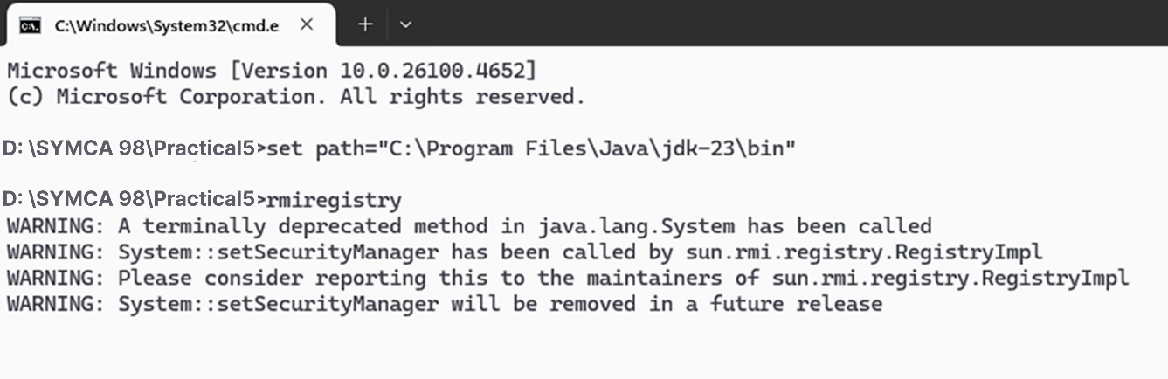

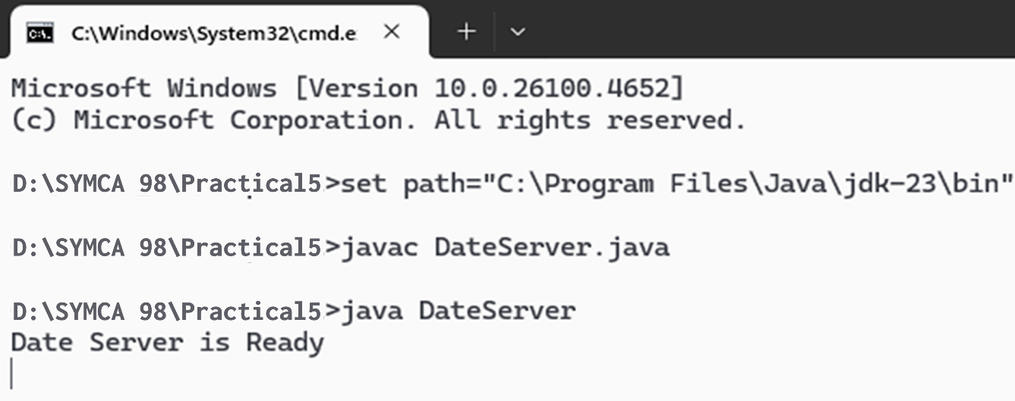

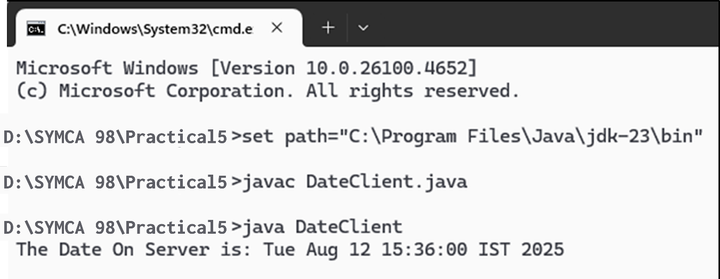

**PRACTICAL NO :- 6**

**TO IMPLEMENT EQUATION SOLVER USING DATAGRAM**

# PRACTICAL NO :- 6

## Aim:- To implement Equation solver using Datagram. The client should provide an equation to the Server through an interface. The server will solve the expression given by the client. (a-b)2 = a2 –2ab + b2; If a = 5 and b = 2 then return value = 52 – 2.5.2 + 22 = 9.

**Code:- serverEqSolve.java:-** import java.io.*; import java.net.*; import java.rmi.*;

public class serverEqSolve

{

public static void main(String[]args)

{

try

{

implEqSolve obj=new implEqSolve(); Naming.rebind("hello",obj);

}

catch(Exception e)

{

System.out.println(e);

}

}

}

## intfEqSolve.java:-

import java.rmi.*;

public interface intfEqSolve extends Remote

{

public int solveEq1(int a,int b)throws RemoteException; public int solveEq2(int a,int b)throws RemoteException; public int solveEq3(int a,int b)throws RemoteException; public int solveEq4(int a,int b)throws RemoteException;

}

**implEqSolve.java:-** import java.rmi.*; import java.rmi.server.*;

public class implEqSolve extends UnicastRemoteObject implements intfEqSolve

{

public implEqSolve() throws RemoteException

{ }

public int solveEq1(int a,int b) throws RemoteException

{

int ans=(a*a)-(2*a*b)+(b*b); return ans;

}

public int solveEq2(int a,int b) throws RemoteException

{

int ans=(a*a)+(2*a*b)+(b*b); return ans;

}

public int solveEq3(int a,int b) throws RemoteException

{

int ans=(a*a*a)-(3*a*a*b)+(3*a*b*b)-(b*b*b); return ans;

}

public int solveEq4(int a,int b) throws RemoteException

{

int ans=(a*a*a)+(3*a*a*b)+(3*a*b*b)+(b*b*b); return ans;

}

}

**clientEqSolve.java:-** import java.io.*; import java.net.*; import java.rmi.*;

public class clientEqSolve

{

public static void main(String[]args)

{

try

{

int num1,num2,res=0,choice;

intfEqSolve object=(intfEqSolve)Naming.lookup("hello");

BufferedReader br=new BufferedReader(new InputStreamReader(System.in)); System.out.println("Equations:-");

System.out.println("1.(a-b)2");

System.out.println("2.(a+b)2");

System.out.println("3.(a-b)3");

System.out.println("4.(a+b)3"); System.out.println("Choose the equation:"); choice=Integer.parseInt(br.readLine()); System.out.println("Enter the value of a and b"); num1=Integer.parseInt(br.readLine()); num2=Integer.parseInt(br.readLine()); switch(choice)

{

case 1:

case 2:

case 3:

case 4:

res=object.solveEq1(num1,num2); break;

res=object.solveEq2(num1,num2); break;

res=object.solveEq3(num1,num2); break;

res=object.solveEq4(num1,num2); break;

default:

System.out.println("Invalid option"); break;

}

System.out.println("the answer is"+res);

}

catch(Exception e)

{

System.out.println("Exception:"+e);

}

}

}

**Output:-**

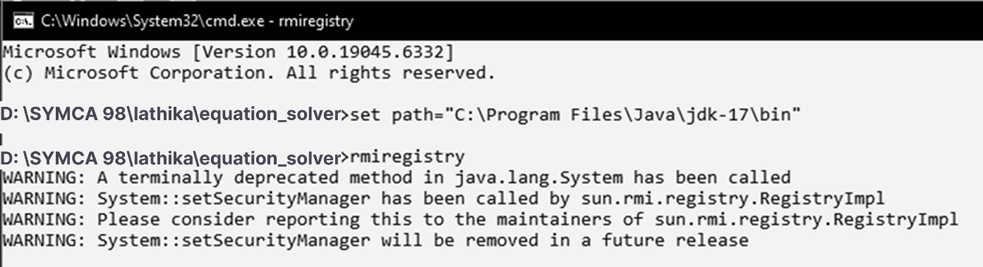

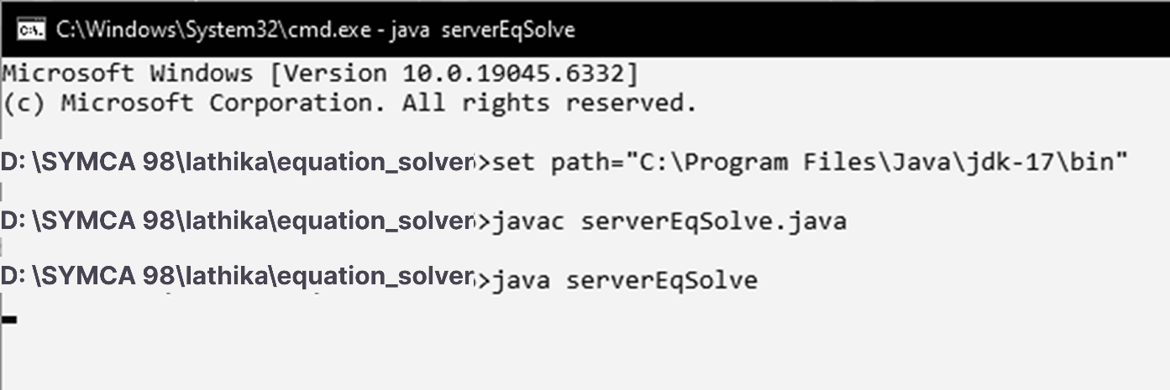

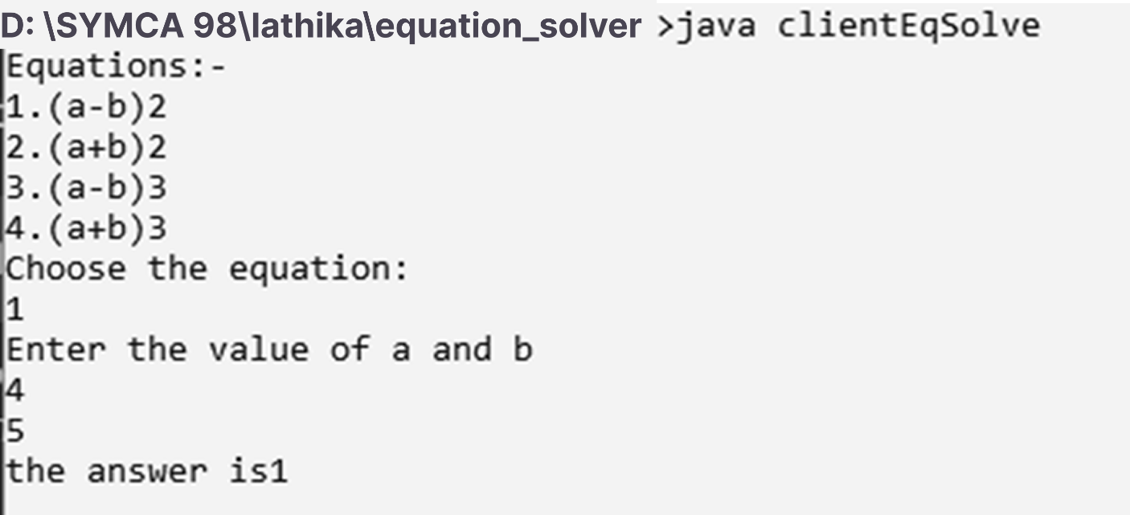

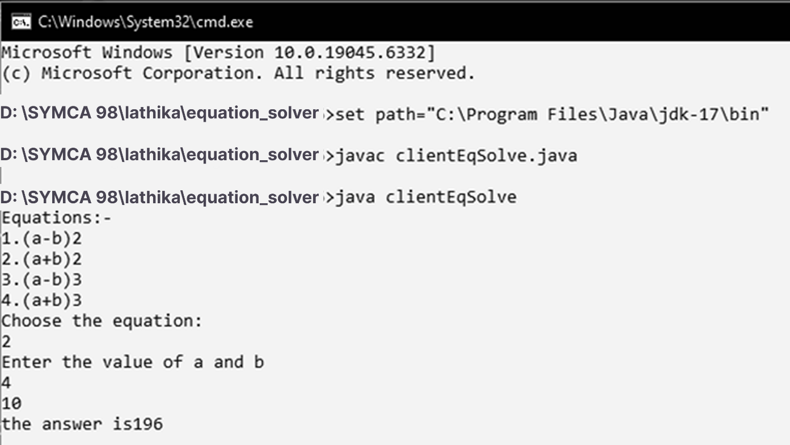

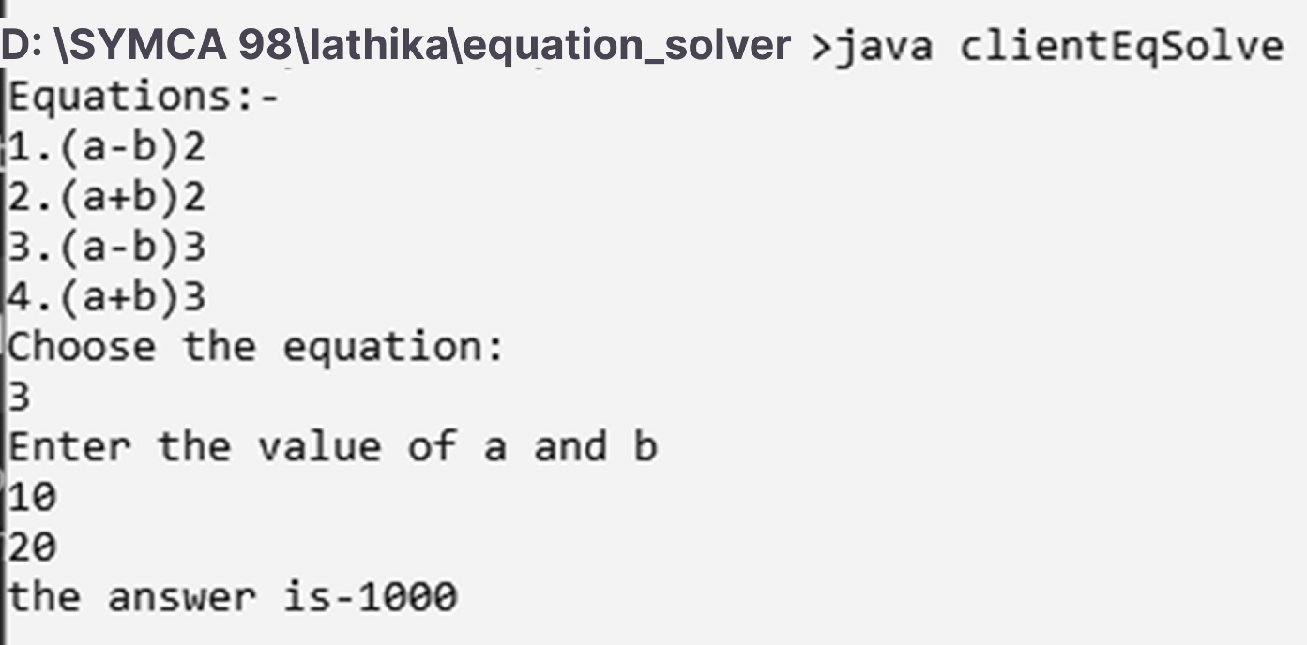

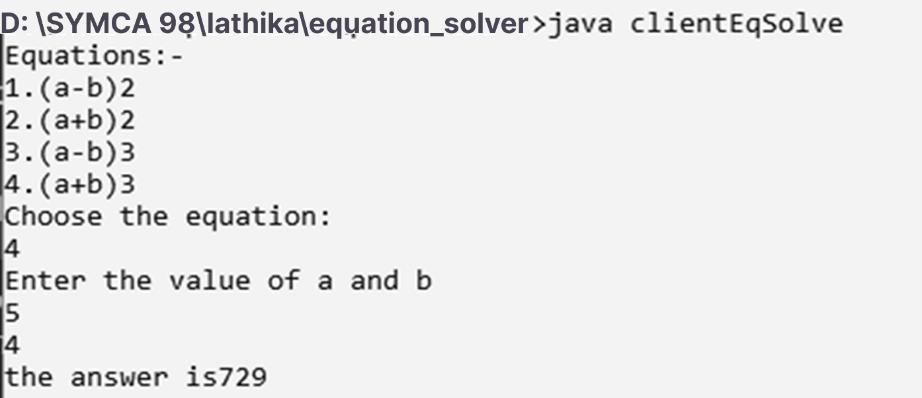

**PRACTICAL NO:-7**

**USE OF REMOTE OBJECT COMMUNICATION AND MYSQL DATABASE**

# PRACTICAL NO:-7

**Aim:- Using MySQL create Library database. Create table Book (Book_id, Book_name, Book_author) and retrieve the Book information from Library database using Remote Object Communication concept.**

**Steps:-**

1. **Create database.**

create database LibraryDB; use LibraryDB;

CREATE TABLE Book(

BookID int,

Book_Name varchar(15), Author varchar(15), Price int,

No_Of_Copies int

);

INSERT INTO Book VALUES (1, 'C++', 'Balagurusamy', 200, 20);

INSERT INTO Book VALUES (2, 'Java', 'Lathika', 400, 30); INSERT INTO Book VALUES (3, 'Let us C', 'Sam', 300, 10); INSERT INTO Book VALUES (4, 'DBMS', 'Om', 300, 10);

INSERT INTO Book VALUES (5, 'c', 'Ria', 300, 10);

INSERT INTO Book VALUES (6, 'DSCC', 'Rupali', 300, 10);

select * from Book;

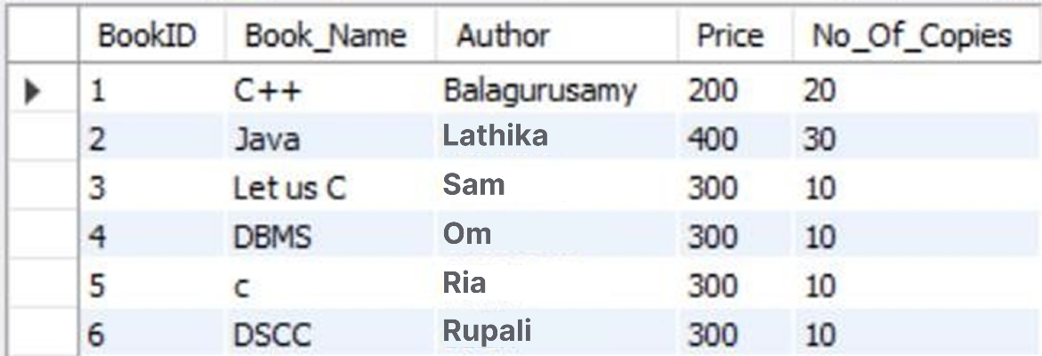

1. Open ODBC Source and add new connection of Library databse.

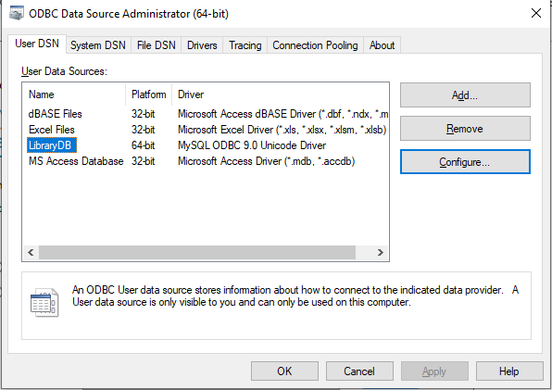

1. Test the Connection.

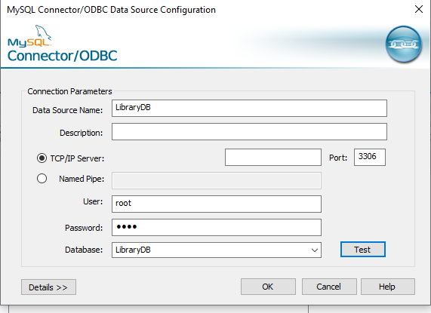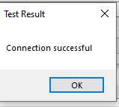

## IDb.java:-

import java.rmi.*;

public interface IDb extends Remote

{

public String getData(String s,String db) throws RemoteException;

}

## DBImpl.java:-

import java.rmi.*; import java.rmi.server.*; import java.sql.*;

public class DBImpl extends UnicastRemoteObject implements IDb

{

String str,str1;

public DBImpl() throws RemoteException

{}

public String getData(String sql,String dsn)

{

String URL="jdbc:odbc:"+ dsn; try

{

Class.forName("sun.jdbc.odbc.JdbcOdbcDriver"); Connection con=DriverManager.getConnection(URL); Statement s=con.createStatement();

ResultSet rs=s.executeQuery(sql); ResultSetMetaData rsmd=rs.getMetaData(); str="";str1="";

for(int i=1;i<=rsmd.getColumnCount();i++)

{

str1=str1+rsmd.getColumnName(i) + "\t";

}

System.out.println(); while(rs.next())

{

for(int i=1;i<=rsmd.getColumnCount();i++)

{

str=str+rs.getString(i)+"\t";

}

str=str+"\n";

}

}

catch(Exception e)

{

e.printStackTrace();

}

return (str1+"\n" +str);

}

}

**DBServer.java:-** import java.rmi.*; public class DBServer

{

public static void main(String[] args)

{

try

{

DBImpl di=new DBImpl(); Naming.rebind("rmi://127.0.0.1/DBServer",di); System.out.println("Server Registered.");

}

catch (Exception e1)

{

e1.printStackTrace();

}

}

}

**DBClient.java:-** import java.rmi.*; import java.io.*;

public class DBClient_P7 {

public static void main(String[] args) { String sql = "", res = "";

try

{

BufferedReader br = new BufferedReader(new InputStreamReader(System.in)); System.out.println("\n*** Books Table ***");

sql = "select * from Book";

String url = "rmi://127.0.0.1/DBServer"; IDb id = (IDb) Naming.lookup(url);

res = id.getData(sql, "LibraryDB");

System.out.println("\n ");

System.out.print(res);

System.out.println(" ");

} // end of try catch (Exception e)

{

e.printStackTrace();

}

}

}

**Output:-**

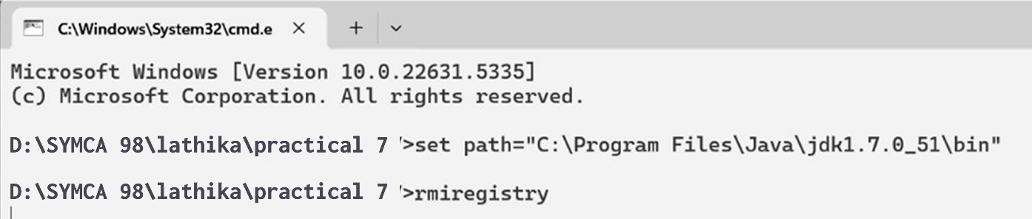

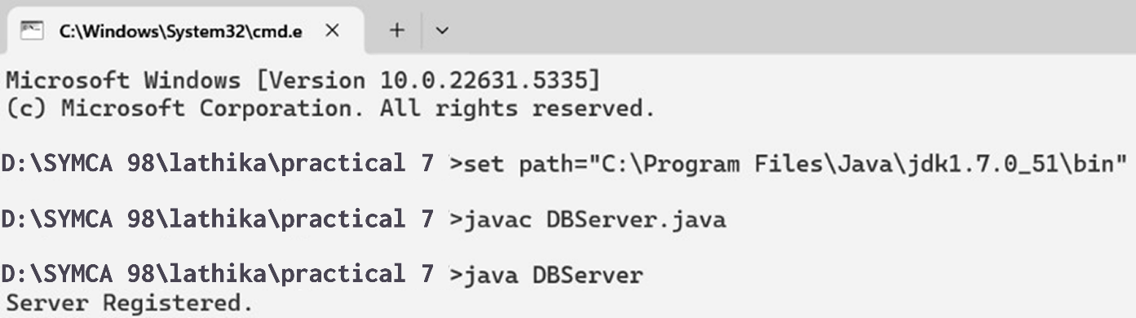

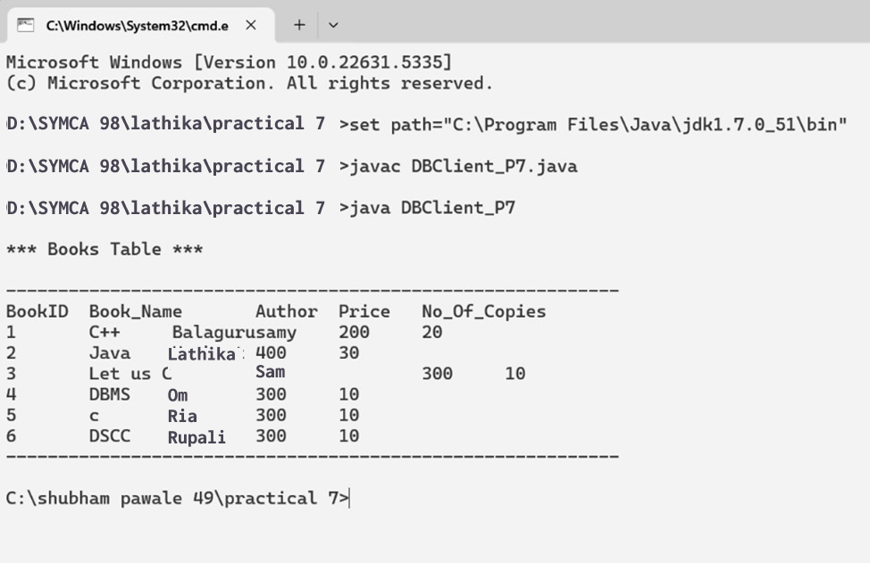

**PRACTICAL NO :-8**

**USE OF REMOTE OBJECT COMMUNICATION WITH MYSQL DATABASE FOR CREATION OF TABLES**

# PRACTICAL NO :-8

**Aim:- Using MySQL create the Elecrtic_Bill database. Create table Bill (consumer_name, bill_due_date, bill_amount) and retrieve the Bill information from the Elecrtic_Bill database using Remote Object Communication concept.**

**Steps:-**

1. **Create database.**

create database MtnlDB; use MtnlDB;

CREATE TABLE Bill(

CustID int,

Customer_Name varchar(15), Bill_Due_Date date, Bill_Amount int

);

INSERT INTO Bill VALUES (1, 'Lathika', '2022-09-21', 200);

INSERT INTO Bill VALUES (2, 'Sam', '2022-09-22', 400);

INSERT INTO Bill VALUES (3, 'Om', '2022-09-23', 300);

INSERT INTO Bill VALUES (4, 'Ria', '2022-09-23', 400);

INSERT INTO Bill VALUES (5, 'Sneha', '2022-09-23', 500);

INSERT INTO Bill VALUES (6, 'Ram', '2022-09-23', 600);

Select * from Bill;

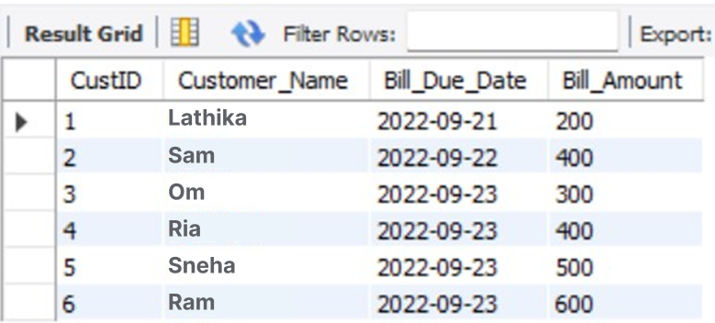

1. Open ODBC Source and add new connection of MtnlDB databse.

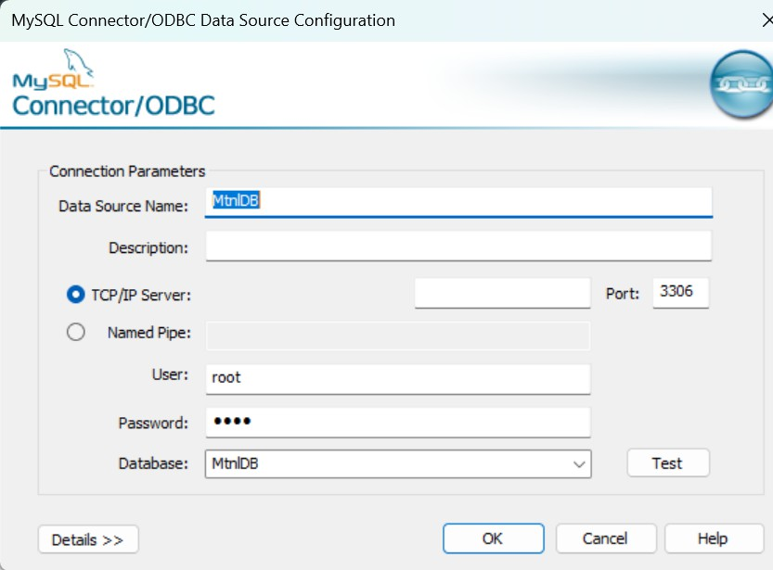

1. Test the Connection.



## IDb.java:-

import java.rmi.*;

public interface IDb extends Remote

{

public String getData(String s,String db) throws RemoteException;

}

## DBImpl.java:-

import java.rmi.*; import java.rmi.server.*; import java.sql.*;

public class DBImpl extends UnicastRemoteObject implements IDb

{

String str,str1;

public DBImpl() throws RemoteException

{}

public String getData(String sql,String dsn)

{

String URL="jdbc:odbc:"+ dsn; try

{

Class.forName("sun.jdbc.odbc.JdbcOdbcDriver"); Connection con=DriverManager.getConnection(URL); Statement s=con.createStatement();

ResultSet rs=s.executeQuery(sql); ResultSetMetaData rsmd=rs.getMetaData(); str="";

str1="";

for(int i=1;i<=rsmd.getColumnCount();i++)

{

str1=str1+rsmd.getColumnName(i) + "\t";

}

System.out.println(); while(rs.next())

{

for(int i=1;i<=rsmd.getColumnCount();i++)

{

str=str+rs.getString(i)+"\t";

}

str=str+"\n";

}

}

catch(Exception e)

{

e.printStackTrace();

}

return (str1+"\n" +str);

}

}

**DBServer.java:-** import java.rmi.*; public class DBServer

{

public static void main(String[] args)

{

try

{

DBImpl di=new DBImpl(); Naming.rebind("rmi://127.0.0.1/DBServer",di); System.out.println("Server Registered.");

}

catch (Exception e1)

{

e1.printStackTrace();

}

}

}

**DBClient.java:-** import java.rmi.*; import java.io.*;

public class DBClient_P8 {

public static void main(String[] args) { String sql = "", res = "";

try

{

BufferedReader br = new BufferedReader(new InputStreamReader(System.in));

System.out.println("\n*** Bill Table ***"); sql = "select * from Bill";

String url = "rmi://127.0.0.1/DBServer"; IDb id = (IDb) Naming.lookup(url);

res = id.getData(sql, "MtnlDB");

System.out.println("\n ");

System.out.print(res);

System.out.println(" ");

} // end of try catch (Exception e)

{

e.printStackTrace();

}

}

}

**Output:-**

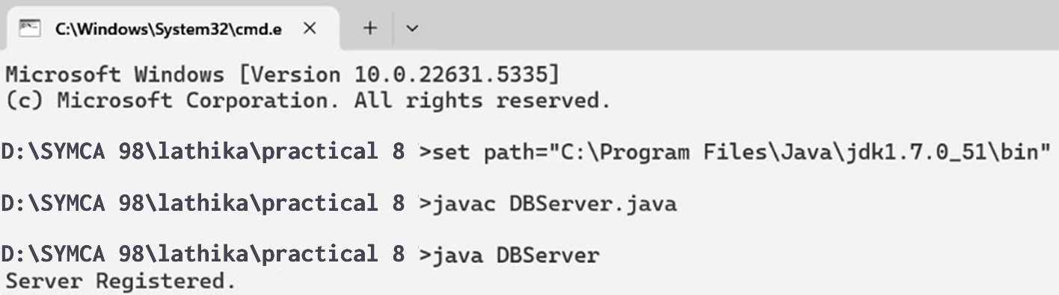

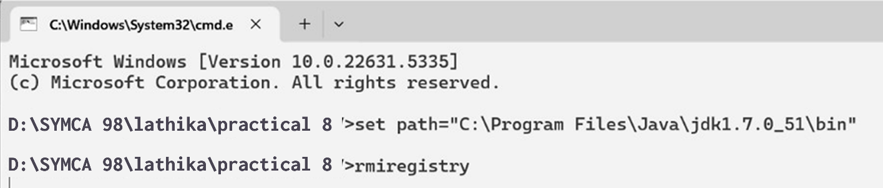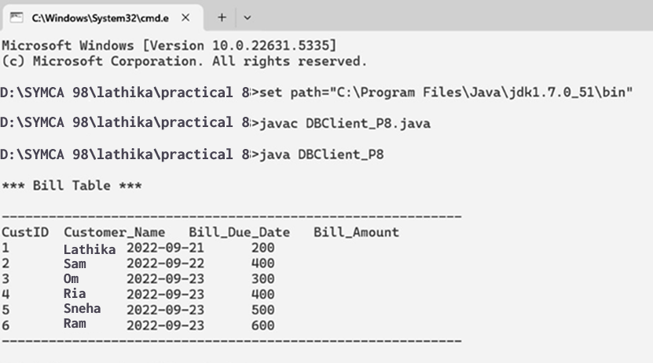

**PRACTICAL NO:- 9**

**IMPLEMENTATION OF MUTUAL EXCLUSION USING TOKEN RING ALGORITHM**

# PRACTICAL NO:- 9

## Aim:- Implementation of mutual exclusion using Token ring algorithm. Code:-

**TokenServer.java:-**

import java.net.*; import java.io.*; class TokenServer

{

public static DatagramSocket ds; public static DatagramPacket dp;

public static void main(String[] args) throws Exception

{

try

{

ds=new DatagramSocket(1000); // ds is the object of DatagramSocket at port 1000 while(true)

{

byte buff[]=new byte[1024];

// data coming from client is in byte form. This data is stored in buff array

// this data is received at server through ds dp=new DatagramPacket(buff, buff.length); ds.receive(dp);

// data in byte form is converted in string form

String str=new String(dp.getData(),0,dp.getLength());

// the data received from client is display at server System.out.println("Message from " +str);

}

}

catch(Exception e)

{

e.printStackTrace();

}

}

}

**TokenClient1.java:-** import java.net.*; import java.io.*; class TokenClient1

{

public static DatagramSocket ds; public static DatagramPacket dp; public static BufferedReader br; static int cp=100;

public static void main(String[] args) throws Exception

{

boolean hasToken; try

{ ds=new DatagramSocket(100); } catch(Exception e)

{ e.printStackTrace(); } hasToken=true;

while(true)

{

if(hasToken==true)

{

System.out.println("Do you want to enter data...(yes/no):");

br=new BufferedReader(new InputStreamReader(System.in)); String ans=br.readLine();

if(ans.equalsIgnoreCase("yes"))

{

System.out.println("ready to send… ");

System.out.println("sending… ");

System.out.println("Enter the data ");

br=new BufferedReader(new InputStreamReader(System.in)); String str="Client-1===> " + br.readLine();

byte buff[]=new byte[1024]; buff=str.getBytes();

ds.send(new DatagramPacket(buff, buff.length, InetAddress.getLocalHost(),

1000));

System.out.println("now sending… ");

}

else if(ans.equalsIgnoreCase("no"))

{

System.out.println("I am in busy state now ");

//sending msg to client-2 String msg="Token";

byte bf1[]=new byte[1024]; bf1=msg.getBytes();

ds.send(new DatagramPacket(bf1, bf1.length,

InetAddress.getLocalHost(), 200));

hasToken=false;

//receiving msg from client-2 byte bf2[]=new byte[1024];

ds.receive(dp=new DatagramPacket(bf2,bf2.length));

String clientmsg=new String(dp.getData(),0,dp.getLength()); System.out.println("The data passed from client2 is "+clientmsg); if(clientmsg.equals("Token"))

hasToken=true;

System.out.println("I am leaving busy state");

}

}

else

{

System.out.println("Entering in receive mode."); byte bf[]=new byte[1024];

ds.receive(dp=new DatagramPacket(bf,bf.length));

String clientmsg1=new String(dp.getData(),0,dp.getLength()); System.out.println("The data passed from Client1 is "+clientmsg1);

if(clientmsg1.equals("Token"));

{

hasToken=true;

}

}

}

}

}

**Tokenclient2.java:-** import java.net.*; import java.io.*; class TokenClient2

{

static DatagramSocket ds; static DatagramPacket dp; static BufferedReader br;

public static void main(String[] args)throws Exception

{

try

{

}

ds=new DatagramSocket(200);

catch(Exception e)

{

e.printStackTrace();

}

boolean hasToken=true;

while(true)

{

//System.out.println("Entering if"); if(hasToken==true)

{

System.out.println("Do you want to enter data(Yes/No):"); br=new BufferedReader(new InputStreamReader(System.in)); String str=br.readLine();

if(str.equalsIgnoreCase("yes"))

{

InputStreamReader(System.in));

System.out.println("Enter Data; "); br=new BufferedReader(new

String msg="Client-2===>"+br.readLine(); byte bf1[]=new byte[1024]; bf1=msg.getBytes();

ds.send(new

DatagramPacket(bf1,bf1.length,InetAddress.getLocalHost(),1000));

System.out.println("Data sent");

}

else

{

//send to client 1.

String clientmsg="Token"; byte bf2[] = new byte[1024]; bf2=clientmsg.getBytes(); ds.send(new

DatagramPacket(bf2,bf2.length,InetAddress.getLocalHost(),100));

hasToken=false;

}

else

{

}

try

{

byte buff[]=new byte[1024];

System.out.println("Entering in waiting/receiving mode."); ds.receive(dp=new DatagramPacket(buff,buff.length)); String clientmsg1=new

String(dp.getData(),0,dp.getLength());

System.out.println("The data is "+clientmsg1); if(clientmsg1.equals("Token"))

hasToken=true;

}

catch(Exception e)

{

e.printStackTrace();

}

}

}

}

}

**Output:-**

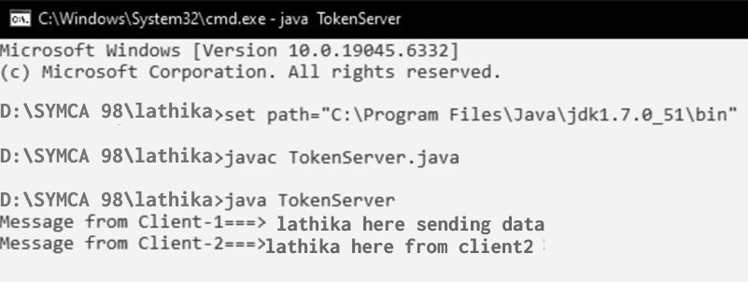

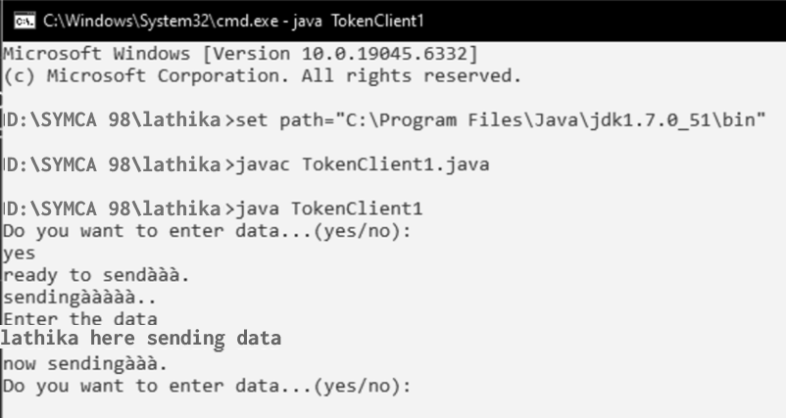

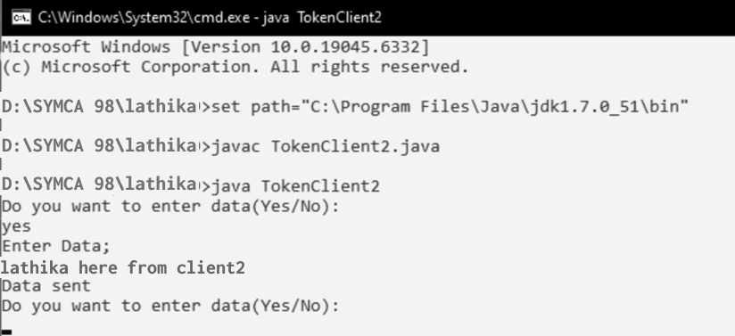

**PRACTICAL NO :- 10**

**IMPLEMENTATION OF ELECTION ALGORITHM**

# PRACTICAL NO :- 10

## Aim:- Implementation of Election Algorithm. Code:-

import java.util.Scanner; public class GFG {

class Pro { int id;

boolean act;

Pro(int id)

{

this.id = id; act = true;

}

}

int TotalProcess; Pro[] process; public GFG() { }

public void initialiseGFG()

{

System.out.println("No of processes 10"); TotalProcess = 10;

process = new Pro[TotalProcess]; int i = 0;

while (i < process.length) { process[i] = new Pro(i); i++;

}

}

public void Election()

{

System.out.println("Process no " + process[FetchMaximum()].id + " fails"); process[FetchMaximum()].act = false;

System.out.println("Election Initiated by 5"); int initializedProcess = 5;

int old = initializedProcess; int newer = old + 1;

while (true)

{

if (process[newer].act)

{

System.out.println("Process " + process[old].id + " pass Election(" + process[old].id

+ ") to" + process[newer].id); old = newer;

}

newer = (newer + 1) % TotalProcess; if (newer == initializedProcess)

{

break;

}

}

System.out.println("Process " + process[FetchMaximum()].id + " becomes coordinator"); int coord = process[FetchMaximum()].id;

old = coord;

newer = (old + 1) % TotalProcess; while (true)

{

if (process[newer].act)

{

System.out.println("Process " + process[old].id

+ " pass Coordinator(" + coord

+ ") message to process "

+ process[newer].id);

old = newer;

}

newer = (newer + 1) % TotalProcess; if (newer == coord) {

System.out.println("End Of Election "); break;

}

}

}

public int FetchMaximum()

{

int Ind = 0;

int maxId = -9999; int i = 0;

while (i < process.length)

{

if (process[i].act && process[i].id > maxId) { maxId = process[i].id;

Ind = i;

} i++;

}

return Ind;

}

public static void main(String arg[])

{

GFG object = new GFG(); object.initialiseGFG(); object.Election();

}

}

**Output:-**

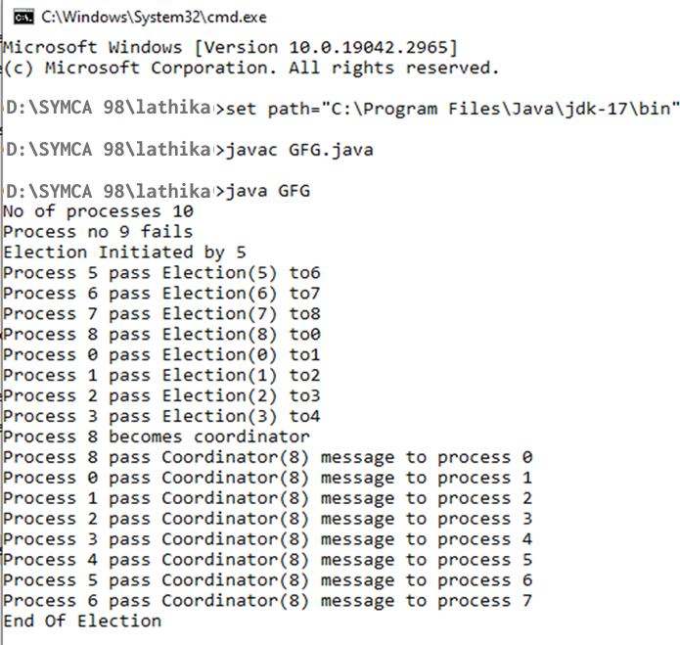

**PRACTICAL NO-11**

**IMPLEMENTATION OF STORAGE AS A SERVICE USING GOOGLE DOCS**

# PRACTICAL NO-11

## Aim:- Implementation of Storage as a Service using Google Docs

**Storage as a Service (SaaS)** is a cloud computing model where storage resources are provided to users on-demand over the internet. It allows users to store, manage, and share data without maintaining physical storage devices.

**Google Docs** is a cloud-based application provided by **Google Workspace (formerly G Suite)**

that allows users to:

* Create and edit documents online.
* Automatically save data to **Google Drive** (cloud storage).
* Collaborate in real-time with multiple users.
* Access files from any device connected to the internet.

## Key Features of Google Docs:

* Cloud-based storage via **Google Drive**
* Real-time collaboration and version control
* Auto-save and revision history
* Cross-platform accessibility (mobile, web, desktop)
* Integration with other Google services like Gmail and Sheets

## Requirements:

* Internet connection
* Google Account
* Web browser (Chrome recommended)

# STEPS:

1. Open any web browser and go to [**https://docs.google.com/**](https://docs.google.com/)

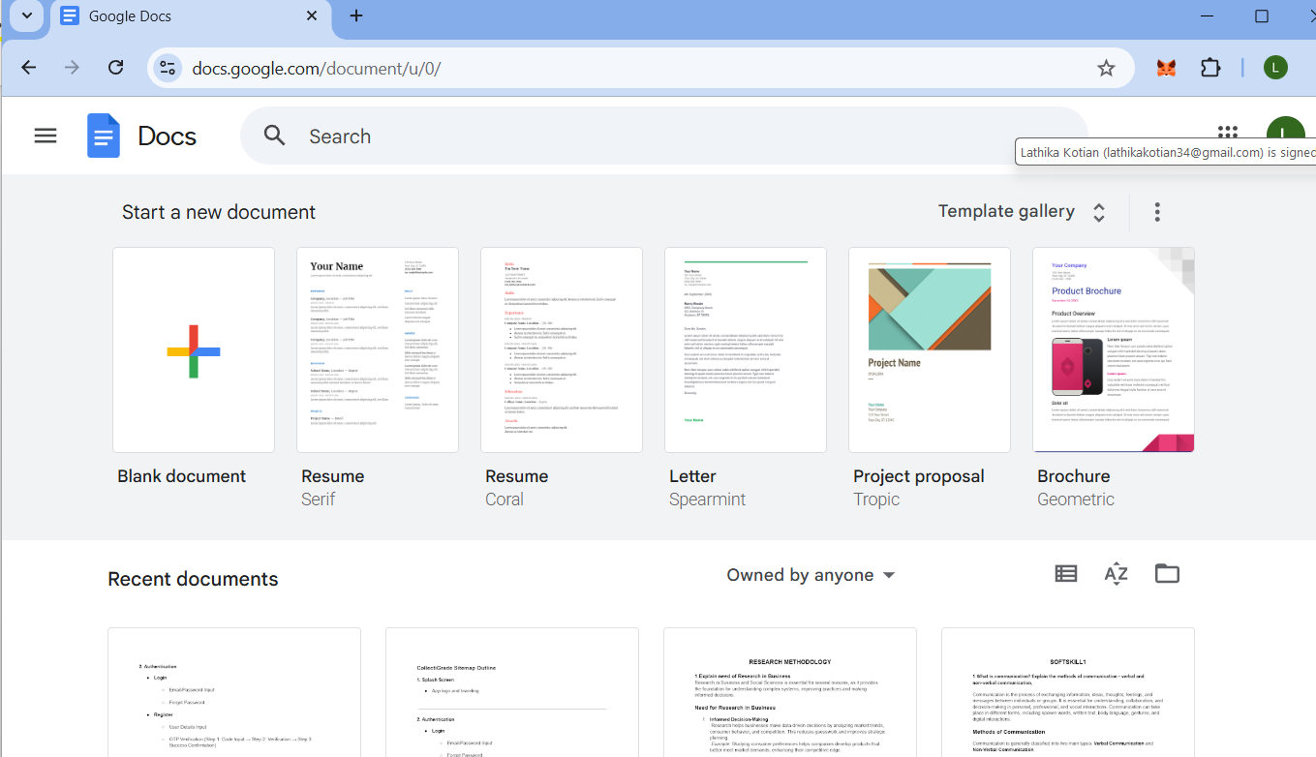

1. Sign in using your **Google account credentials**.
2. Click on **“Blank”** to create a new document.
3. Type or paste your desired content.

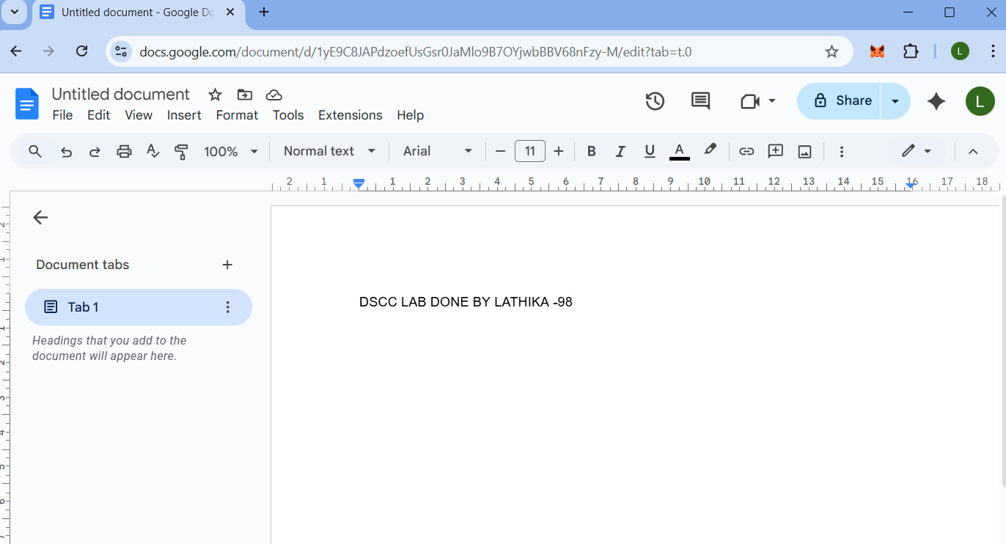

1. Observe that all changes are **automatically saved** in **Google Drive**.



1. To share the document:
   1. Click on the **“Share”** button in the top right corner.
   2. Enter the **email addresses** of collaborators.

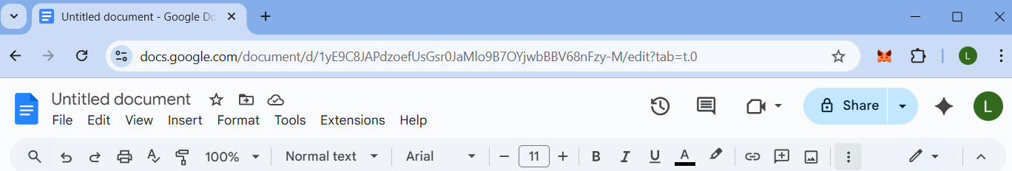

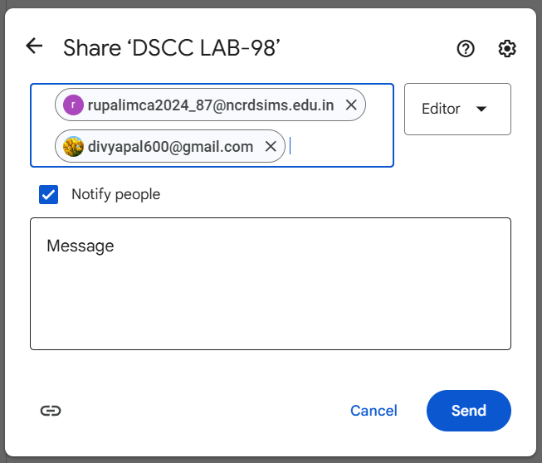

* 1. Set access permissions (Viewer, Commenter, or Editor).

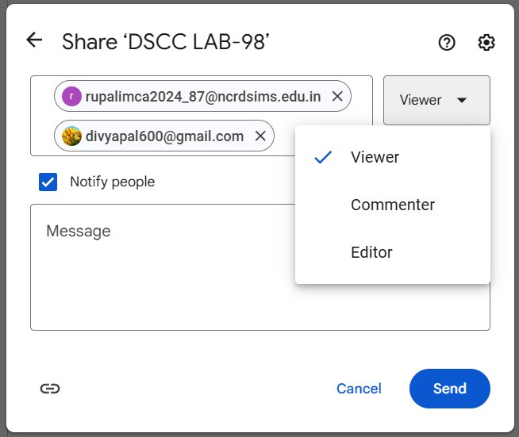

1. Collaborators can now **edit or comment** on the document in real-time.
2. To access the stored file later, go to **https://drive.google.com/** and open the saved document.

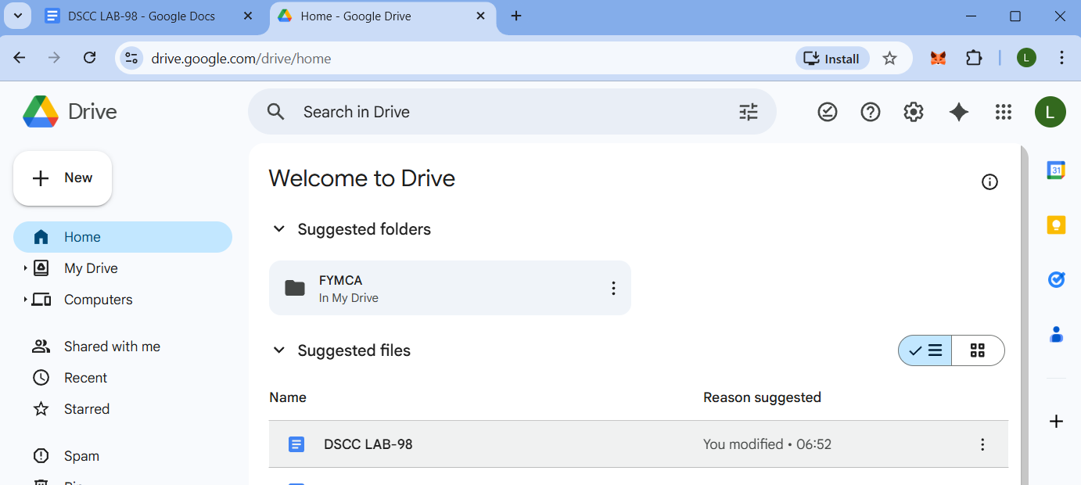

## Advantages:

* Easy access from anywhere
* Real-time collaboration
* Automatic backup and updates
* Cost-effective (no hardware maintenance)

## Applications:

* Online document creation and sharing
* Cloud-based team collaboration
* Educational and office report generation
* Remote data storage and retrieval

Google Docs effectively demonstrates the **Storage as a Service (SaaS)** concept by providing users with a **cloud-based environment** for creating, editing, storing, and sharing documents seamlessly without the need for local storage.

**PRACTICAL NO:- 12**

**IMPLEMENTATION OF IDENTITY MANAGEMENT.**

# PRACTICAL NO:- 12

## Aim:- Implementation of Identity Management. Steps :

Step1: Open the following link <https://aws.amazon.com/> Step2: Go to my Account-> AWS management console

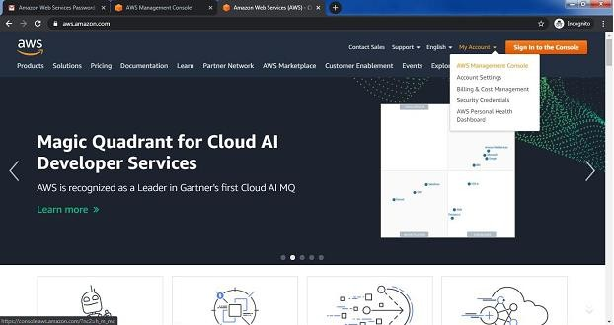

Step3: click on Create new user AWS account

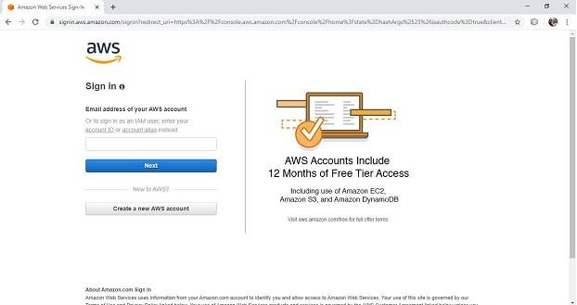

Step4: Fill all the details and click on Continue

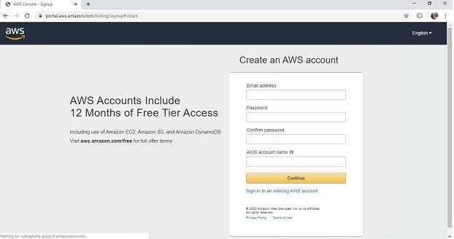

Step5: Fill your contact number and Home address and click on ***create account and continue*** Step6: Now most curtail step AWS will ask for credit card and debit card details. You have to close the browser

Step7: now again open the link <https://aws.amazon.com/>

Step8: Go to my Account->AWS Management console

Enter your ID and click on next, After that enter password and click on sign in

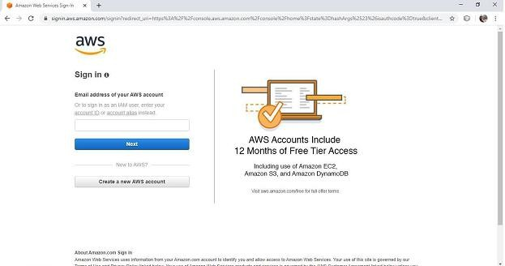

Step 9: you will get the following screen

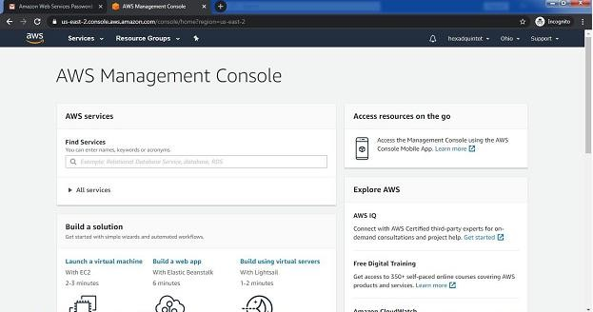

Step 10: Go to My Security credential

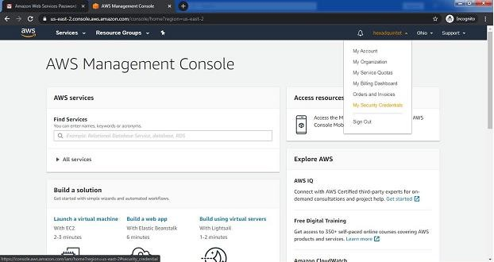

Step 11: now click on user

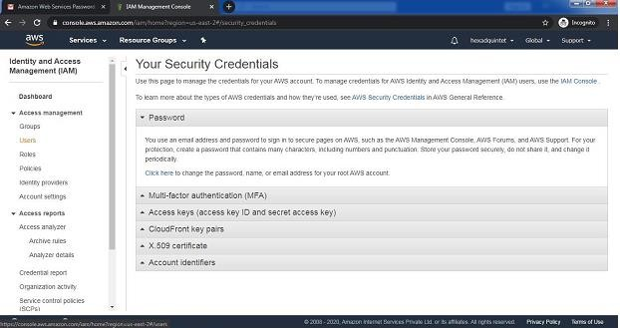

Step 12:Click on add user

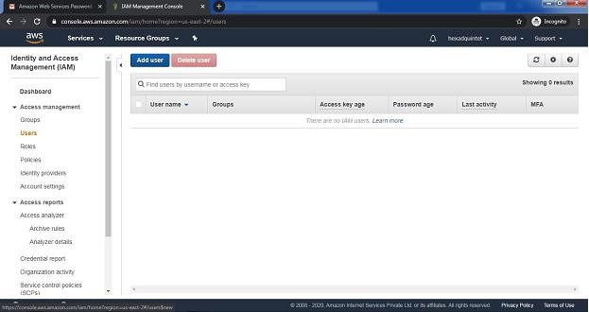

Step 13:Provide the user name and check the check box in front of ***programmatic access*** and ***AWS Management console Access*** and enter the password for new user Click on ***custom password*** and click on next permission

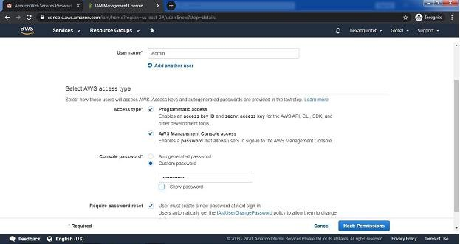

Step 14: click on create Group

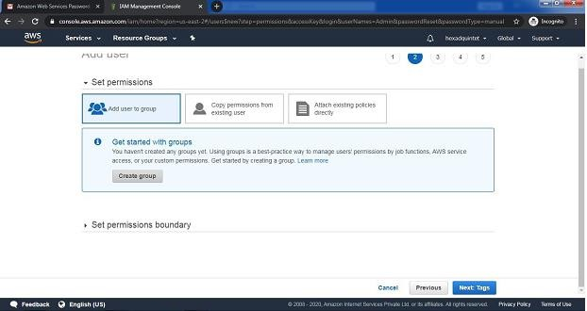

Step15:fill the information and click on Create Group

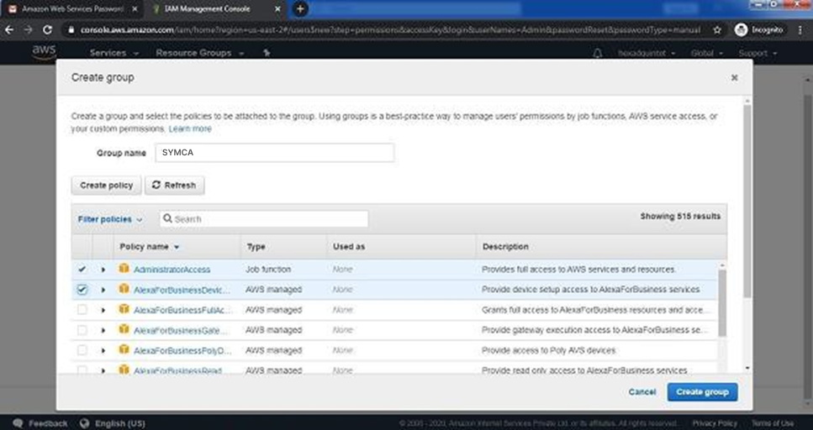

Step16:click on next tag leave blank , again click on next review leave as it is and click on create user

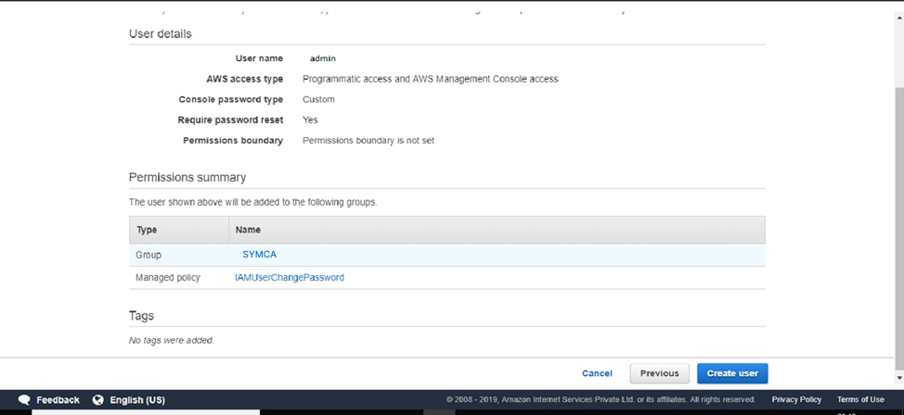

Step 17: click on close

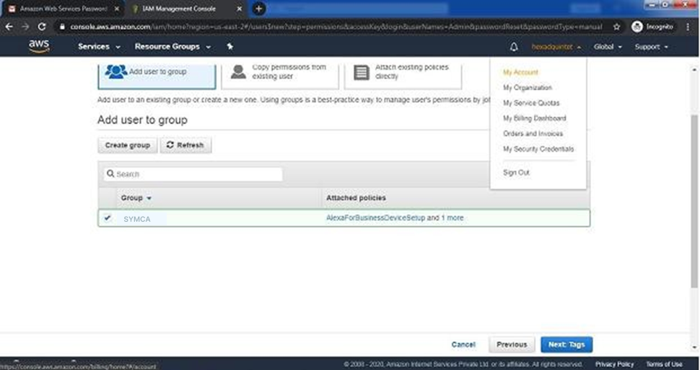

And COPY Account ID

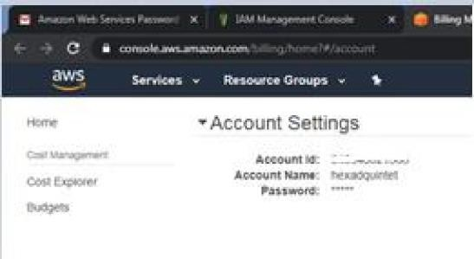

Now logout the admin account and try to login as user(newly created) . Step 18: again Go to my Account->AWS Management console

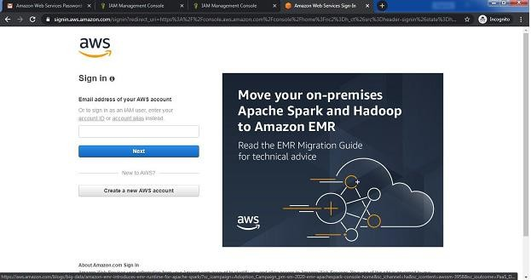

Click on next Provide the Account ID username and password and click on sign in It will ask you to change the password which is been set by administrator

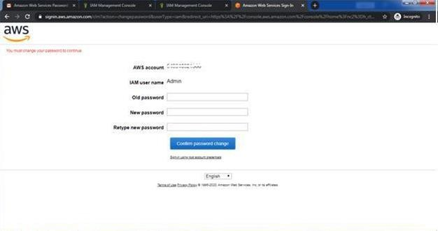

Yow will redirect to home screen

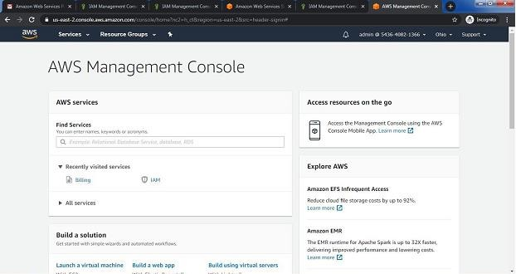

**Conclusion:** Hence we have studied the concept and implementation of identity management using amazon aws.

**PRACTICAL NO :- 13**

**CREATION OF VIRTUAL MACHINE ON ANY CLOUD PROVIDER**

# PRACTICAL NO :- 13

## Aim:- Create a virtual machine (VM) on any cloud provider ( AWS/Azure/GCP) of your choice with the specifications: Operating System, VM Type, Disk Size, Public IP, Network Rules Once created, verify that the VM is running and submit a screenshot of the instance details and a brief description of the steps you followed.

**Step1:** Create an account in AWS cloud and fill all the necessary information for the login and add debit card details for the further process.

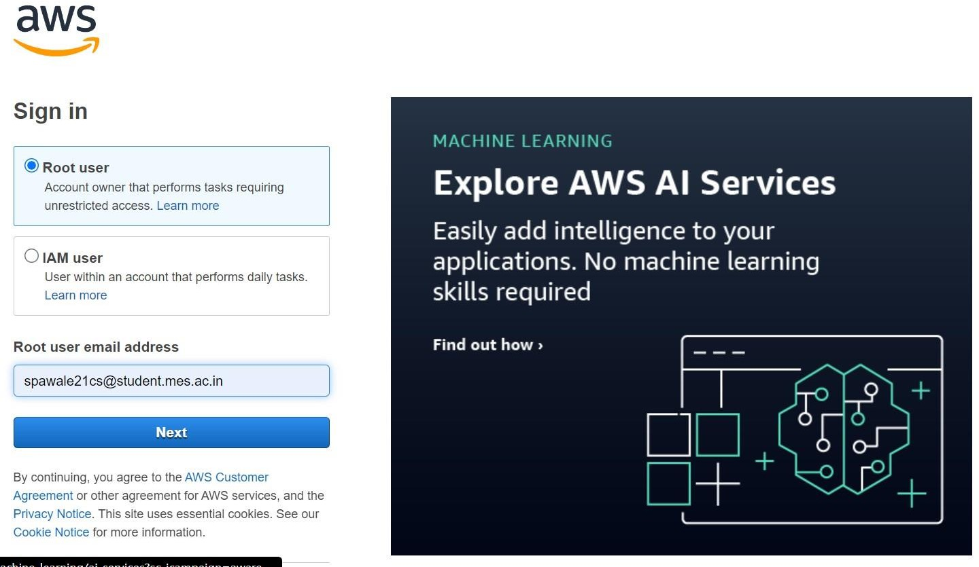

**Step2:** Go to services and search EC2 and then click on instance running>>launch instance.

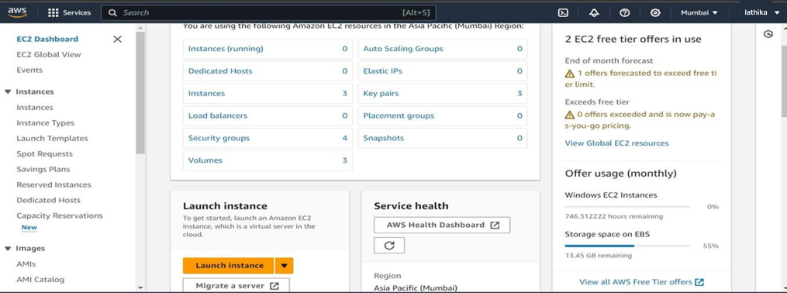

**Step 3:** Go to services search EC2 and then click on instans running>>launchinstance

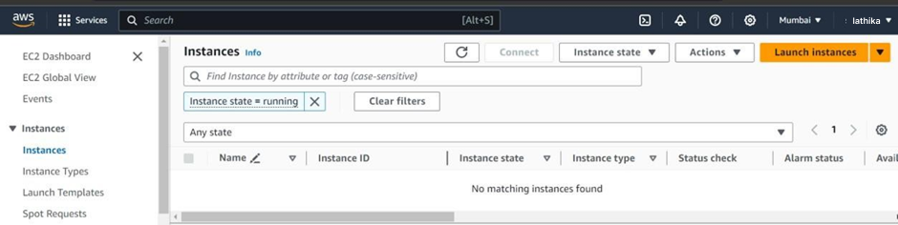

**Step 4:** Click on Launch Instances>> give name to an instance>> select Microsoft windows server base 2019 as an AMI and in network setting allow both http and http

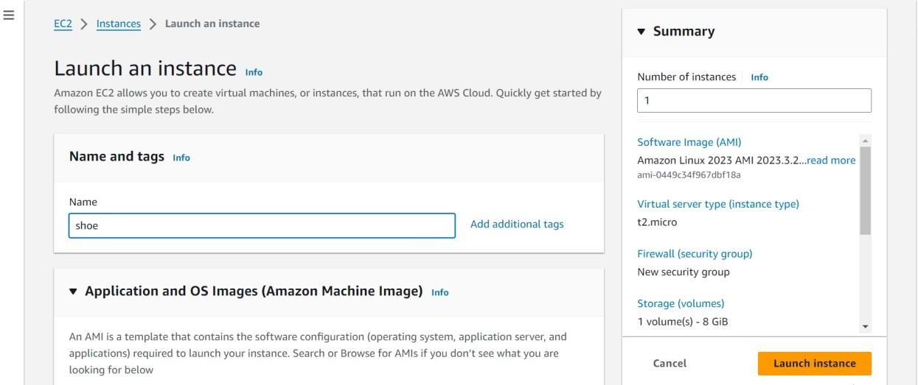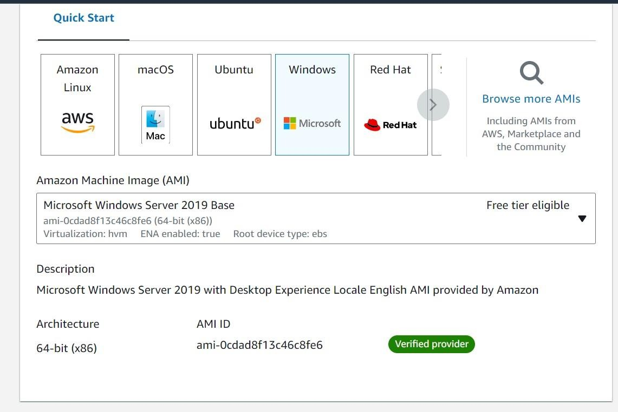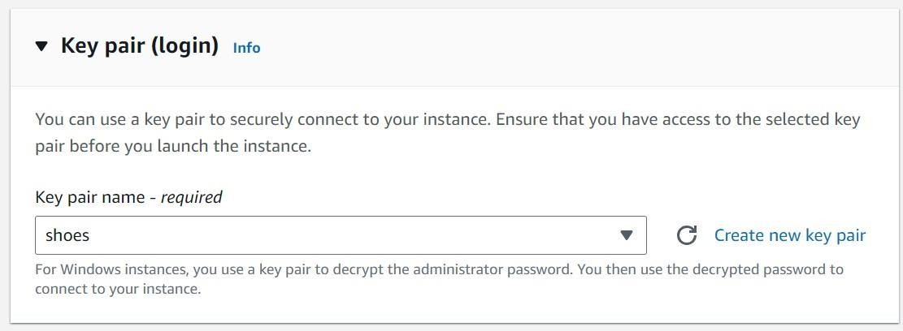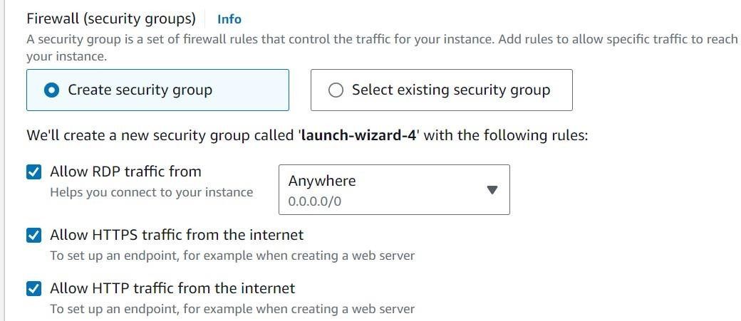

**Step 5:** In downloads you will able to see the file .pem and then simply launch the instance and then go to view all instances.

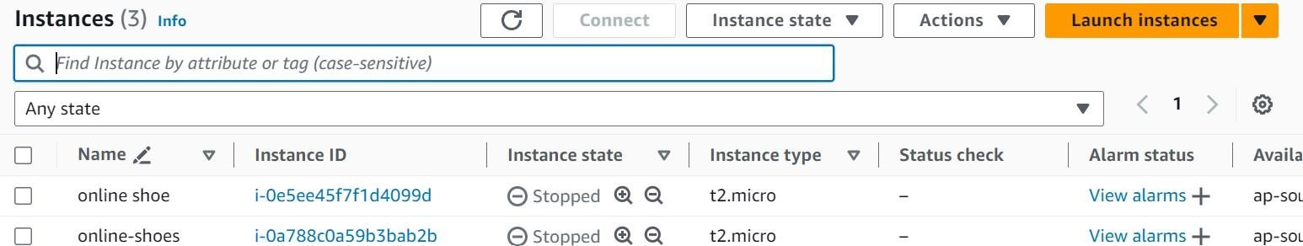

**Step 6**: You can see the project instance right click on that and connect it.One frame will open go to RDP client and download the remote desktop.

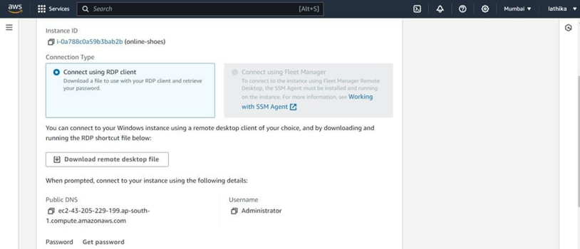

**Step 7:** Below that Go to get password.

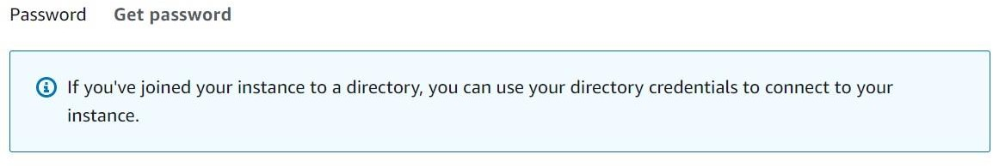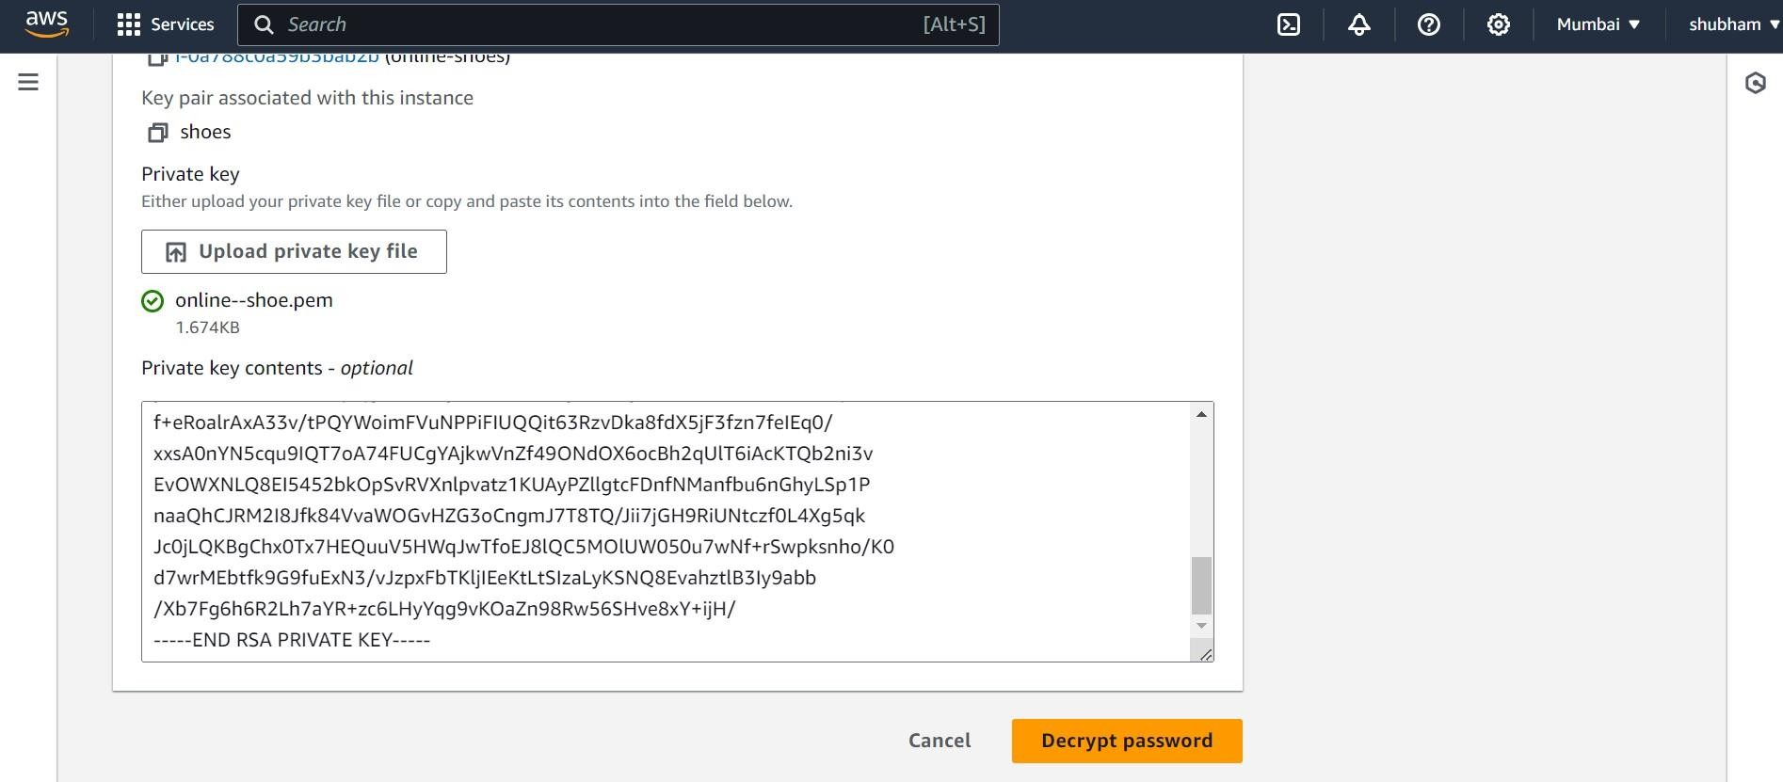

Step 8: Upload your .pem file and click on decrypt password.

Step 9: You will get and password just copy that and in downloads open that window Remote desktop and give password to it for login.

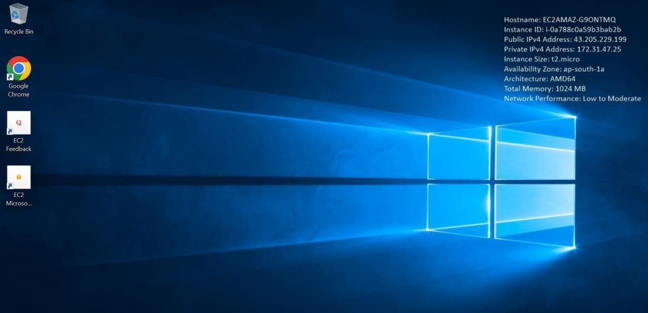

**Step 10:** Now your window is ready for the deployment of the project. Now go to windows security and off the firewall setting go we can redirect to that page

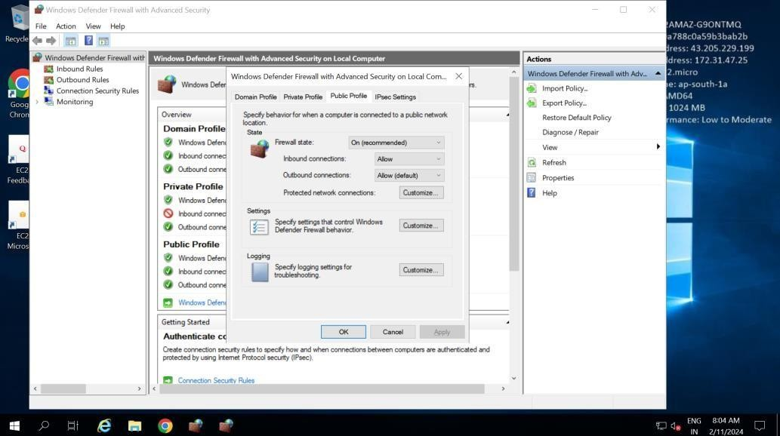

**Step 11:** download the xampp server Now copy your project and paste it in that in xampp- htdocs .

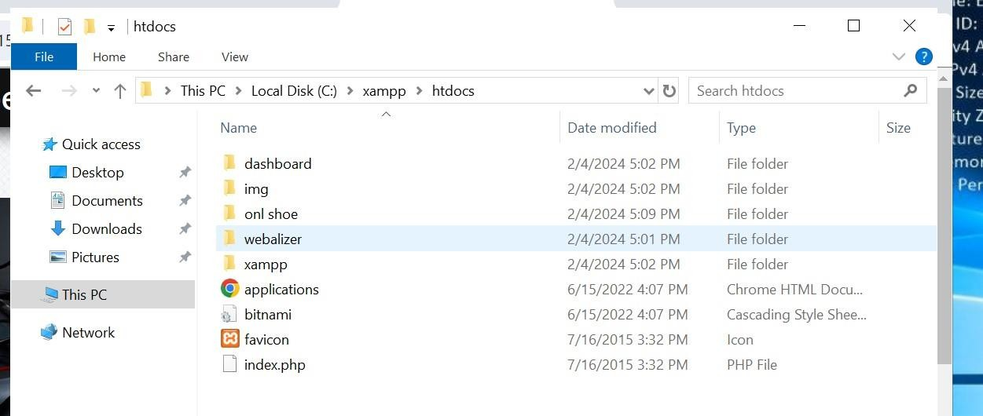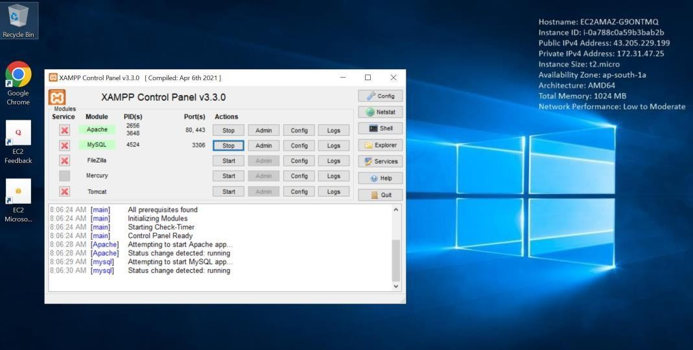

]

**Step 12:** Start Apache and MySQL and go to admin as shown above. And create a database and import the SQL file in it to get tables.

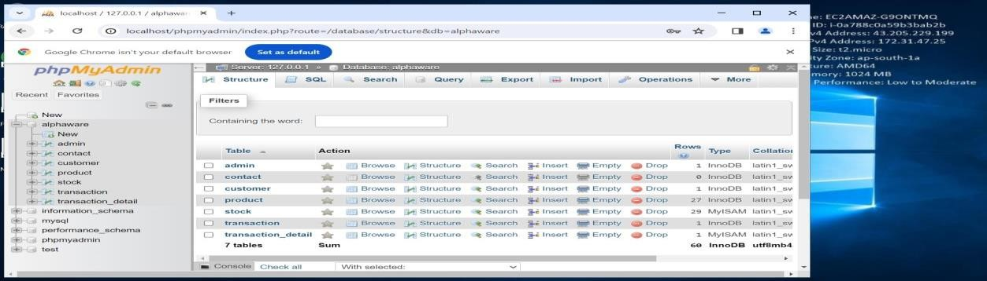

**Step 13:** Now simply go to chrome and search localhost/onl shoe Which my file name given in the htdocs. Now you can add details and it will refect into your database also.

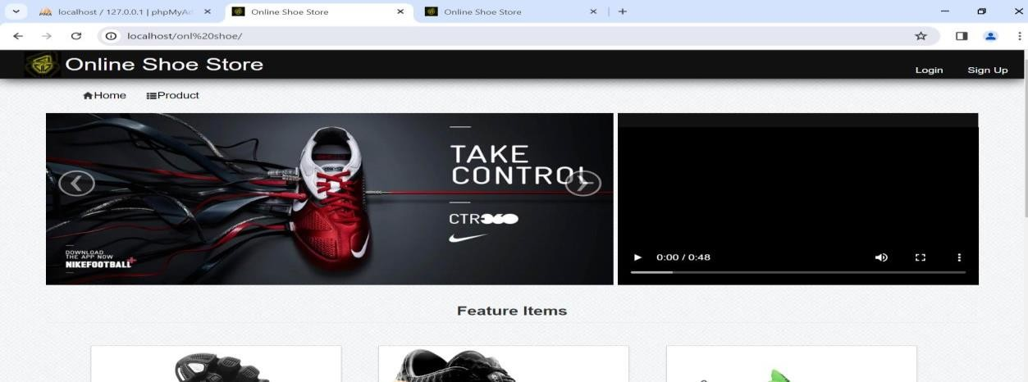

**Step 14:** Now go to new tab and search IP address/your project [(http://15.206.70.95/onl%20shoe/home.php)](http://15.206.70.95/onl%20shoe/home.php)) This will redirect your project to the http server.

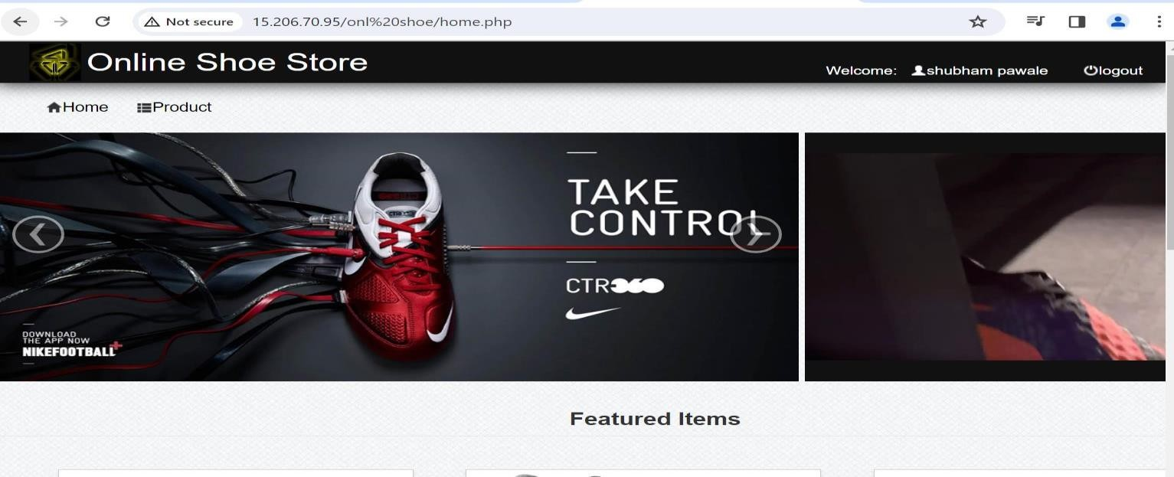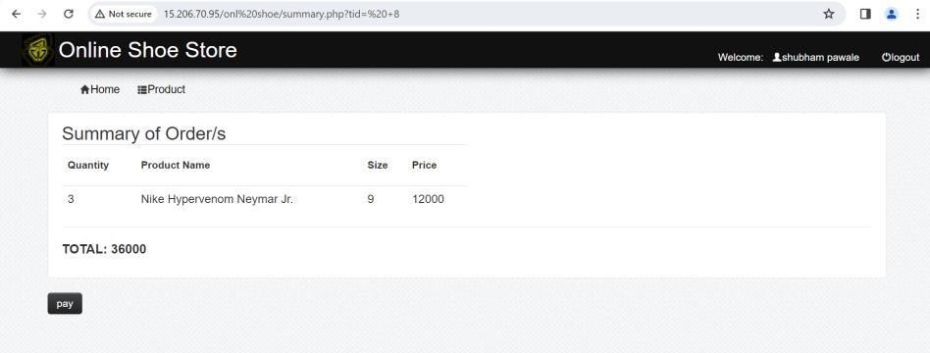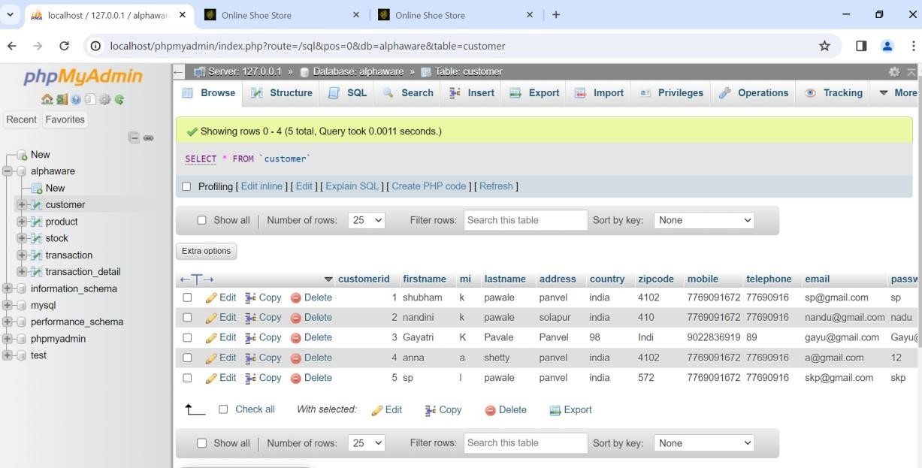

**PRACTICAL NO-14**

**INSTALL VITUAL BOX / VMWARE ON WINDOWS OPERATING SYSTEM**

# PRACTICAL NO-14

# Aim:- Install Virtual Box / VMware / Equivalent open-source cloud Workstation with different flavours of Linux or Windows OS on top of Windows 8 and above.

# Steps:

## Step 1. Download Oracle VirtualBox

[https://www.virtualbox.org/wiki/Download](https://www.virtualbox.org/wiki/Downloads)

Go to the site and download the VirtualBox Installer

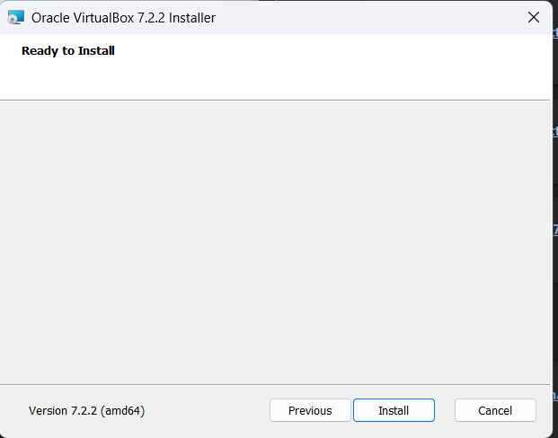

* 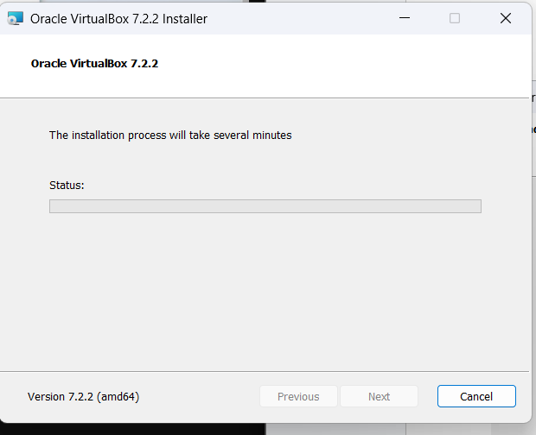Begin the installation.
* 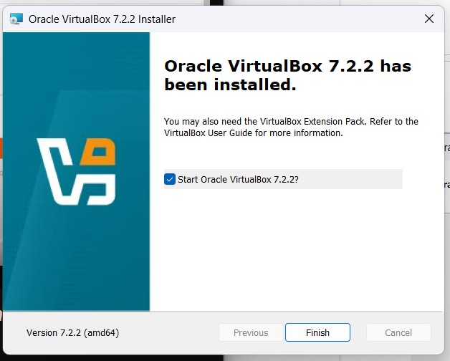Installation is complete.
* Launch VirtualBox Manager.

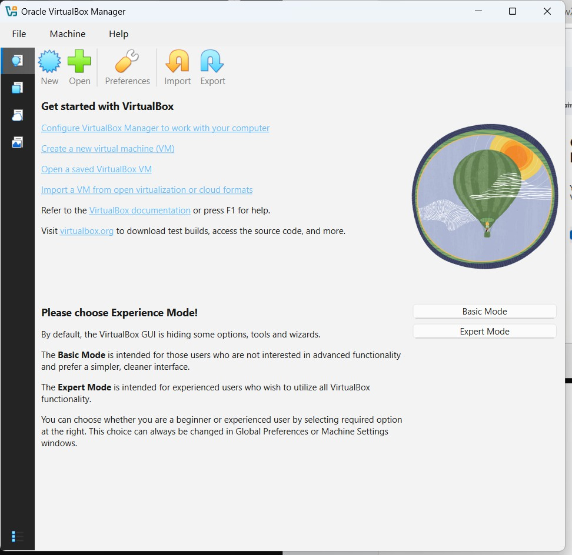

**Step 2:** Download Ubuntu ISO Image <https://ubuntu.com/desktop>

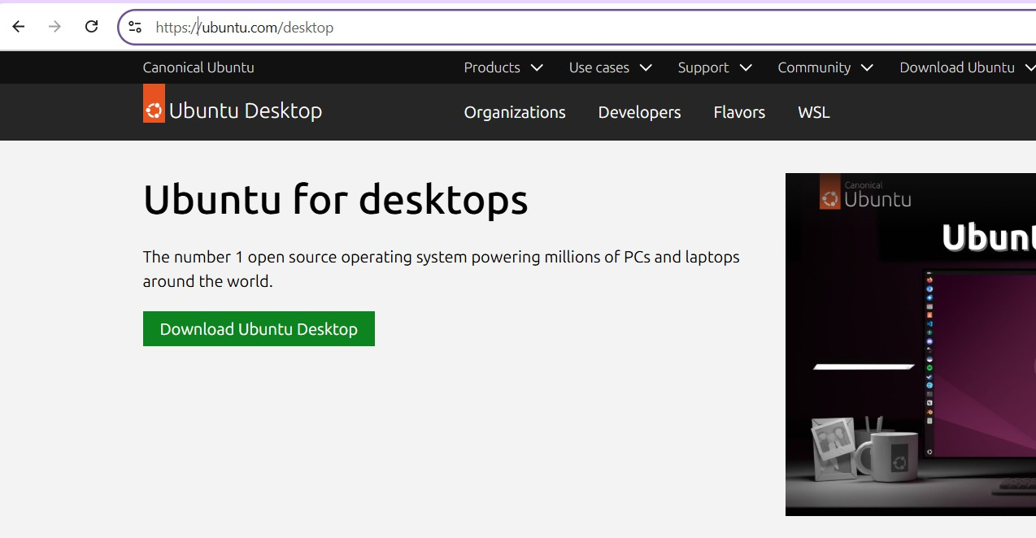

* 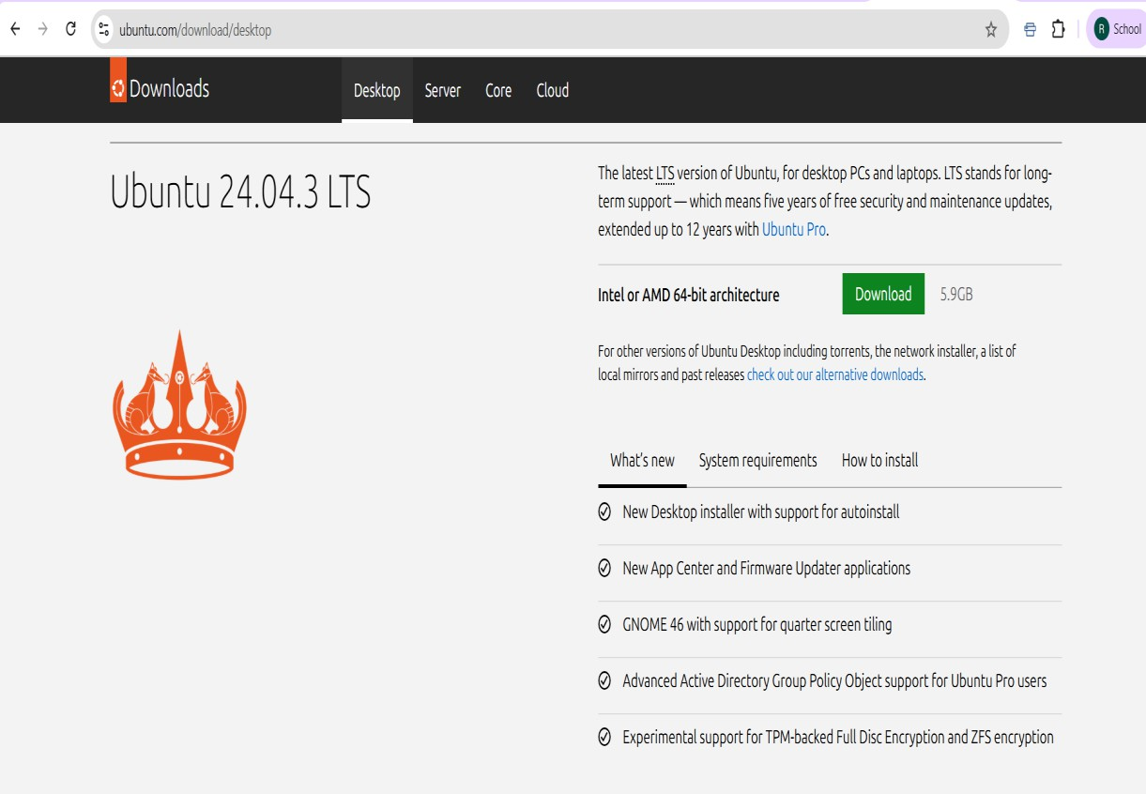Navigate to the download section.
* Download the ISO file.

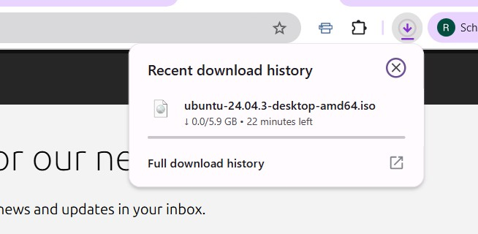

* Locate the downloaded ISO file.

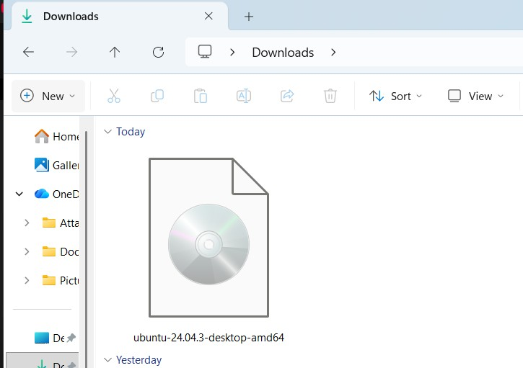

**Step 3:** Create a New Virtual Machine (VM).

* 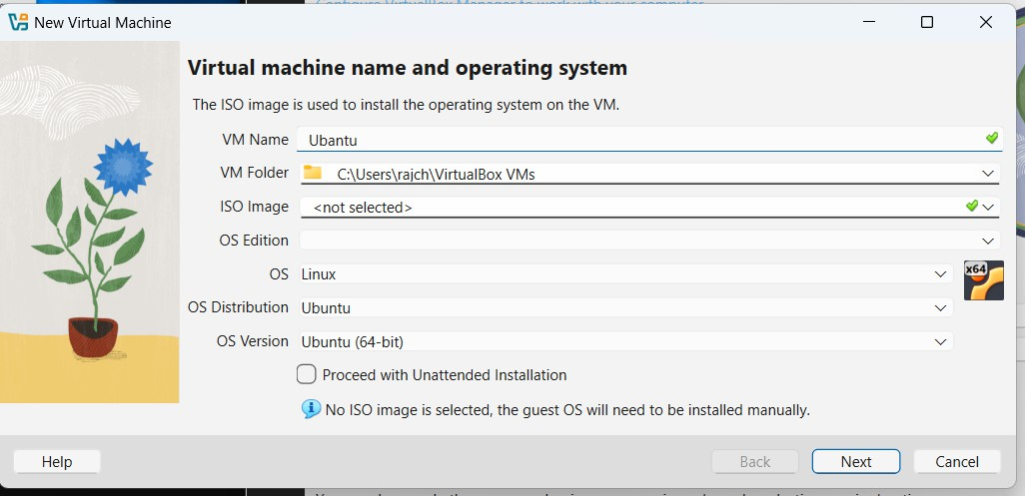Start creating a new VM and define its name and OS type.
* Specify the virtual hardware resources for the VM.

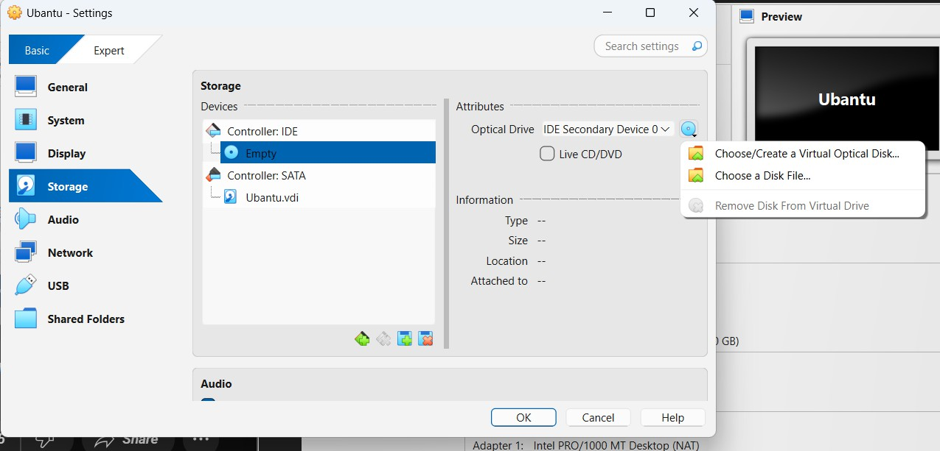

* Review the VM configuration summary.

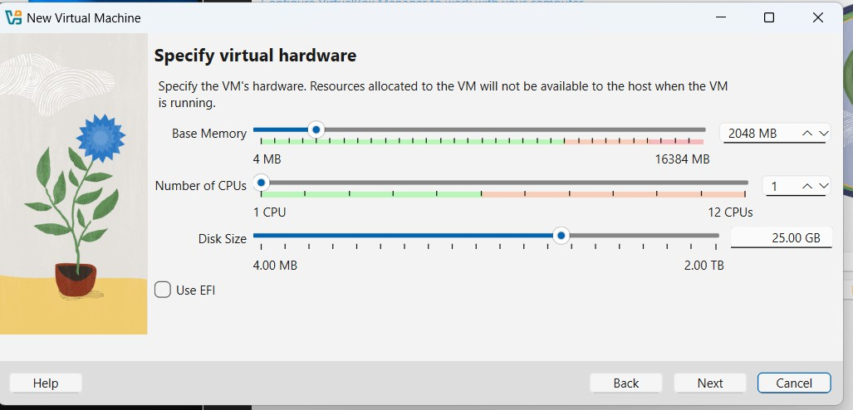

* Review the VM configuration summary.

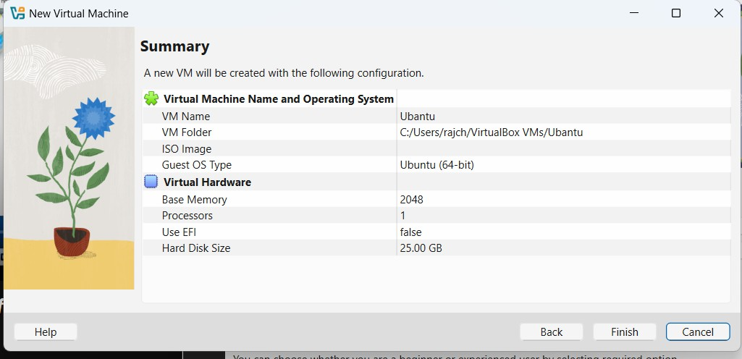

* 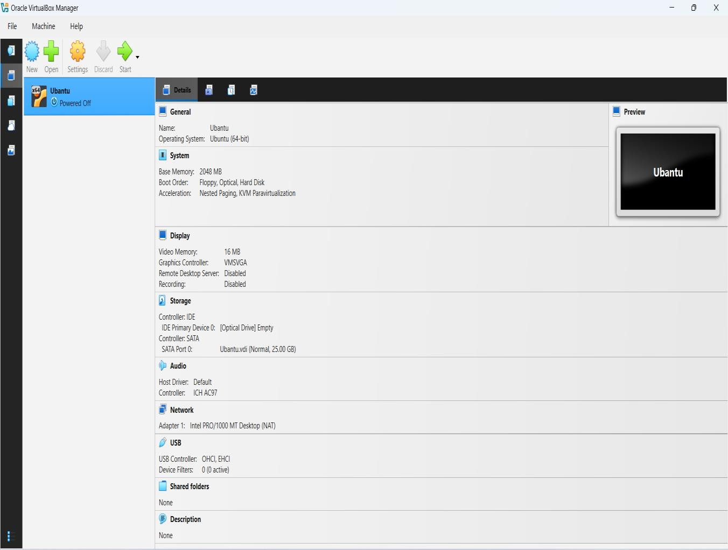View the newly created VM in the Manager.

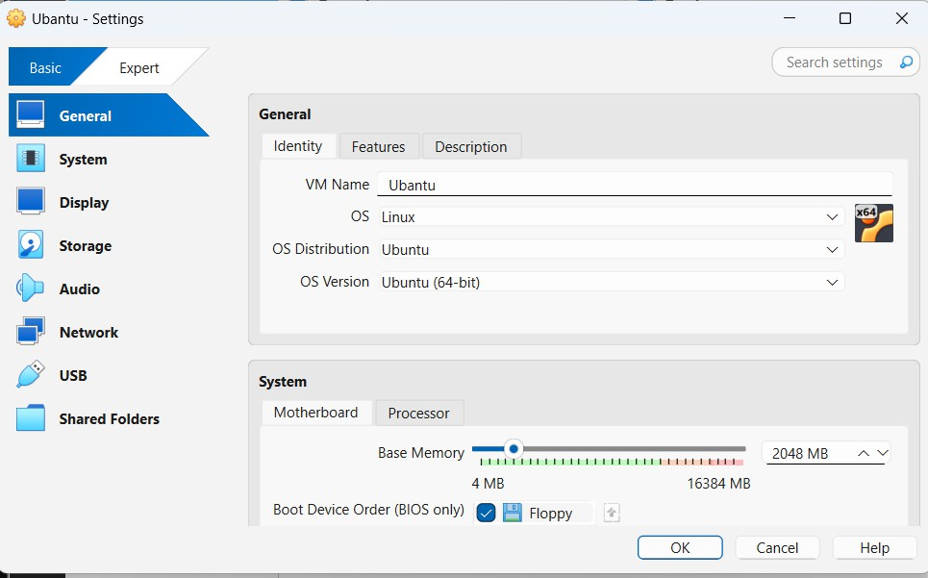**Step 4:** Mount the ISO to the VM

* Go to Storage settings and select the virtual optical drive.



* Select the downloaded ISO file.

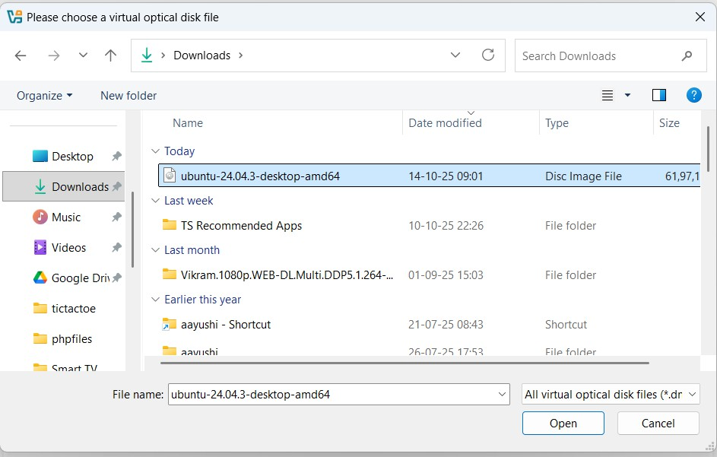

* Confirm the ISO selection.

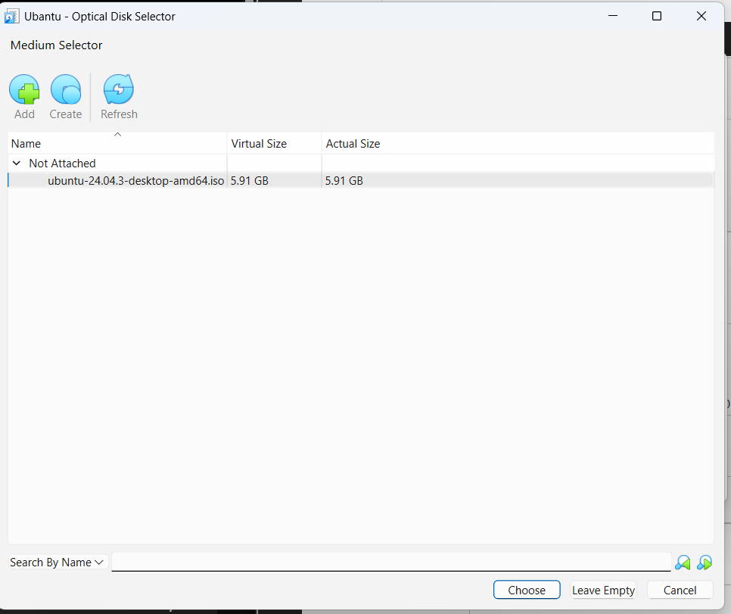

* Verify the ISO is mounted.

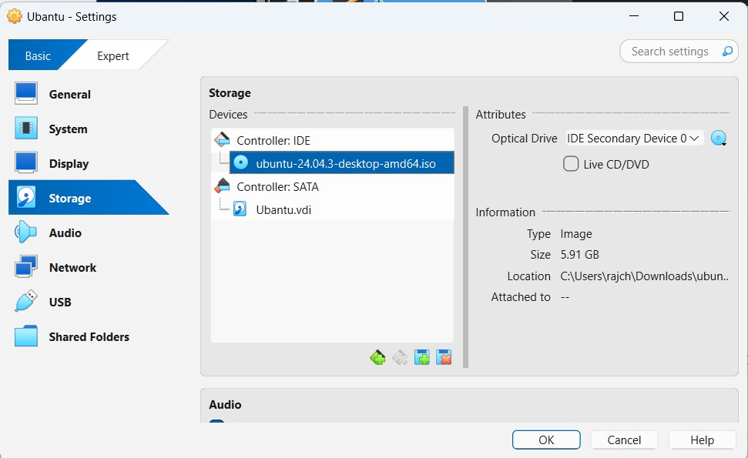

**Step 5:** Install Ubuntu within the VM

* 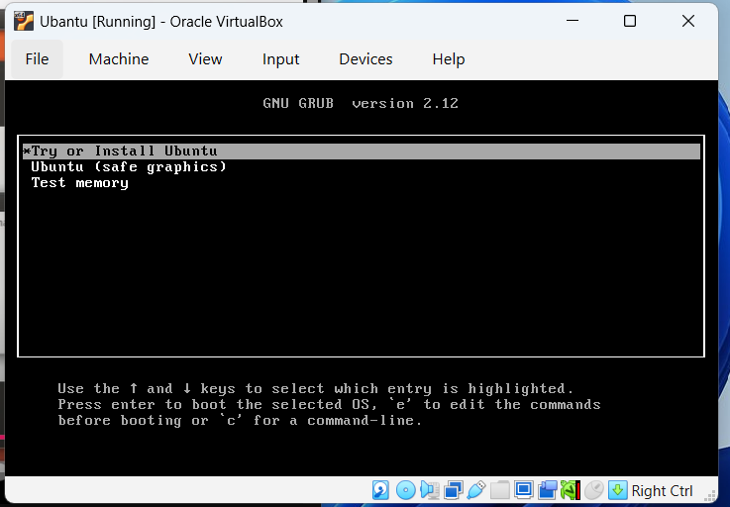Start the VM and select the installation option.
* Select the desired keyboard layout.

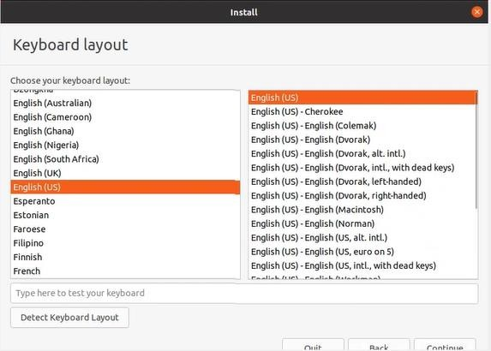

* 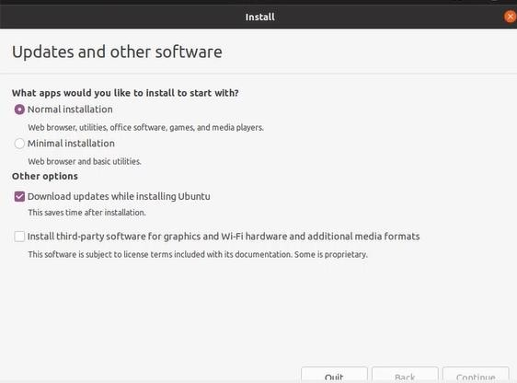Choose installation and update preferences.
* Select the installation type

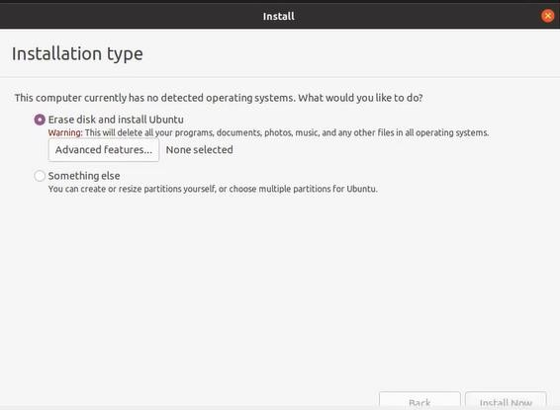

* Set the time zone/location

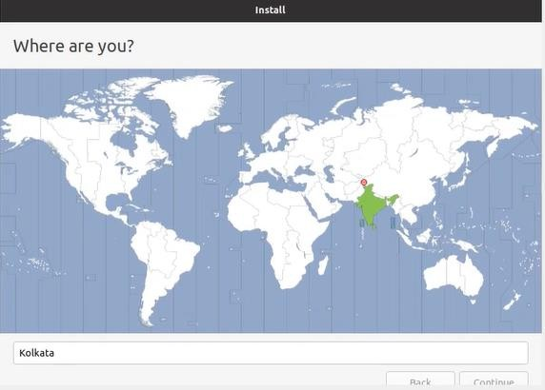

* Create the user account.

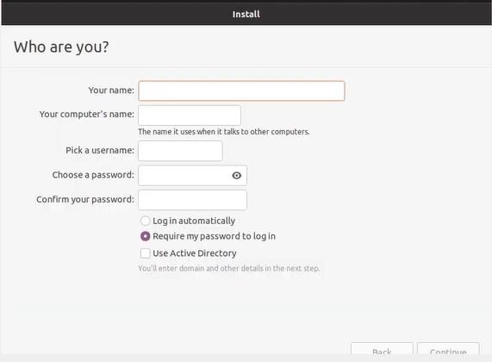

* Installation progress screen.

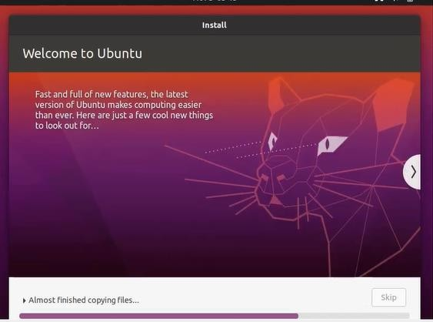

* 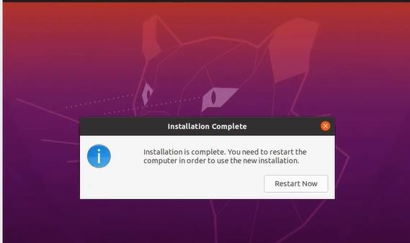Installation is complete.
* Post-install login/account setup.

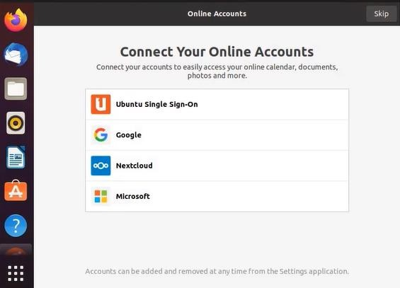

* 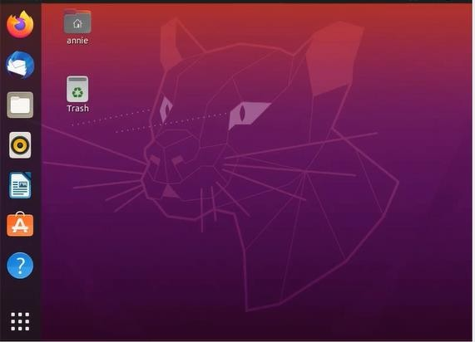The final running Ubuntu Desktop.